Table of Contents
Part 1 – The Process
The Fundamentals
Introduction
The Testing Process
The Test Plan Template
Discovery/Plan
Prepare
Execute
Report
Real World Examples – Why the plan is so important
Plan
Introduction to Planning
The Test Plan Document
Engagement Goals, Objectives and Success Criteria
Testing Goals, Objectives and Success Criteria
The Application and Environment
The Data
Pre-built Data Tests
Self Feeding Data Tests
Reviewing The Plan
Sample Test Plans
Test Plan For Contoso eCommerce
Test Plan For River Bank
Proper Use Cases and Scenarios
Example 1 – “School’s Back In Session”
Example 2 – “Are You Ready For Some Football?”
Building the Test Plan Items
Building the Load Profile
Explanation of the difference between USERS and VUSERS
Choosing the Proper Load Model
Choosing the Proper Numbers
Additional Load Profile Considerations
Too Many Use Cases
Too Fast
Need to use multiple scenarios
Don’t Count It Twice
Multiple Acceptance Criteria for the Same Item
To Think or not To Think
Prepare
Scenarios
Use Cases
Load Profiles
Data; Start Creating
Harness Creation
Application, Environment and Rig Preparation
Final Test Plan Review
Chapter XX - Updated Samples
Preparation For Contoso eCommerce
Preparation For River Bank
Execute
Mission Control (The Work Room)
“Fire in the Hole!” (Test Execution and Analysis)
“Medic!”(Finding and Fixing)
The Daily Standup
Chapter XX - Sample Executions
Executing On Contoso eCommerce
Executing On River Bank
Report
The Summary Report
Closing the feedback loop
Sample Reports
Reporting On Contoso eCommerce
Reporting On River Bank
Part 2 – The Tools
Visual Studio Web and Load Testing Tools
Test Rigs and Test Harnesses
Visual Studio Test Rig
Visual Studio Test Harness
Web Test Information
Creating a new webtest
Suggestions for maintaining readable and usable Declarative Webtests
Declarative Webtest Architecture
Webtest
Webtest Request
Transaction Timer
Comment
Conditional/Loop
Included Webtest
Plugins and Rules
Webtest Execution
Steps in a test
How to process results and correlate webtests
Unit Test Information
Unit Test Execution Order
Load Test Information
Load Test Settings to Remember
Load Test Architecture
Load Test Execution
Advanced Topics
Performance Counters
Initial Test Analysis
Log Analysis
Tooling Your Application For Testing
Final Thoughts
Part 3 – References
Definitions
Execution Checklist
Items that need to be added somewhere in the doc
How timeouts play into analysis
How can a 90% value be less than an average time value

Introduction

Part 1 – The Process

The Fundamentals
Load performance testing is a part of an application’s lifecycle that is often overlooked or not given enough planning/execution time and resources. It is also (unfortunately) one of the more difficult parts to get correct. Accurate load testing, whether to simply collect applications statistics or to tune and optimize your application requires the participation of several groups of people, each with clear roles and requirements, along with a solid plan, accurate input data, appropriate load profiles, realistic environment(s), and a clear set of goals that everyone agrees upon.

The Load Testing Process
In today’s world of DevOps and Continuous Delivery, there seems to be a feeling that Load testing efforts are starting to become less important, or can be covered by proper analytics in the production realm. While there is a lot of value to be gotten from proper production monitoring and well managed rollouts and scalable environments, the industry has not yet reached a point where we can rely solely on Continuous Testing/Delivery and analytics. We still need good old-fashioned load testing.
Callout - There are many types of “Performance Testing”, and several definitions for the term “Load Testing.” So, before we dive into our discussion, I want to provide some clarity about what I mean by “Load Testing.”
Load Testing – a testing effort that creates external load against an application (or set of applications) to
- Analyze how the system will behave under a given load
- Troubleshoot the system and make changes to improve the behavior of the system
- Determine necessary system requirements for given amounts of load

The next several chapters of this book will introduce you to the four portions of a successful load performance testing engagement. These are:
- Discovery/Plan: Set the goals/objectives and success criteria. Determine the requirements for meeting these and the efforts to complete the engagement. Build a list of actionable items and assign appropriate personnel to these items.
- Prepare: build the testing artifacts and data, ensure that tooling and environments will be ready for testing.
- Execute: Execute the tests, analyze the results, perform other tuning/testing/tweaking efforts that were defined in the Planning portion. Repeat this process until the desired goals are met.
- Report: Provide the findings to the stakeholders, incorporate feedback into the development process, document any necessary outcomes for support and/or end users, etc. (e.g. Close the Feedback Loop).

Real World Examples – Why the plan is so important
Before we walk through the different phases of testing, I want to share a few real-world examples of successes and failures in engagements. These examples are meant to illustrate the importance of following all four steps of the ‘Test and Attack’ process.

Get your simulators correct
In November of 2006, I moved over to the Microsoft Testing Services Labs team after spending 10 years supporting and debugging IIS and web server applications. My very first engagement was a “shadow” gig (I went onsite with my mentor to learn how the team worked). When we started talking to the customer about their application, we learned that there was a 3rd party web service that they used in production. This service would not be available in our testing environment. They said that they had already written a stub to use for testing. I thought to myself “Cool! This customer seems to know what they are doing!” My mentor wasn’t so easily impressed. He started asking questions about the stub and learned that it resided on the same machine as the application that used the service. He said that he wanted it to be on a separate machine, so he gave me the task of helping the customer re-write it to run on a separate machine.
Three weeks later, the customer got to our labs and we setup the testing environment and started running tests. We immediately saw average response times shoot up above 20 seconds. The customer said they had never seen this in their testing before, but it looked suspiciously like an issue they saw in production occasionally, but could not reproduce. We started digging into the issue and finally found that the server hosting the web service simulator was improperly configured and was causing calls to be serialized. They had never seen this in their testing because they had the simulator on the same machine as the application and therefore they never ran into the issue with the server configuration. By asking them to move the simulator off-box, my mentor made the test environment more realistic and exposed an issue that the customer had been missing for a long time.

Get your definitions aligned
Shortly after that engagement, I was given an opportunity to fly solo, and I was excited. I wanted to show that I was ready to handle the big league. The next few months were one of the roughest periods in my 24+ year career at Microsoft, but they also proved to be the most valuable.
The customer had an application with the UI written in PowerBuilder. The application’s UI was hosted on Citrix Servers and it talked directly to SQL server. There was no middle tier to emulate with a test harness. We would use Load Runner (which has a Citrix emulator) to drive the UI for our testing. My mentor had already cautioned me that developing this type of harness was tedious and time-consuming, so I was well prepared to add plenty of extra hours to our estimate for the development once I finished my scoping. I headed off to the customer for a full day of scoping discussions. I was introduced to the lead developers, shown the application, and spent several hours talking with management about the requirements for the testing. We determined that there were somewhere between 5-7 use cases that they needed to execute, and that all of them needed to be run concurrently. I had already counted on estimating 3-4 days per use case (my mentor had helped me come up with this figure). With all of this information, we worked up an estimate and sent it to the customer. It consisted of 6 weeks of development and prep time for the test harness.
A week later, I was given the green light to start work. I spent that week getting a copy of the application setup in a development environment, a copy of the use cases, setting up Load Runner and learning the things I would need to build the harness. As I started drilling into the “use cases” they had sent, I began to get a little nervous. The first use case was broken down into 6 different sets of user steps. Each set of user steps appeared to be a full use case! I looked at the second use case and found 7 different sets of steps. The third use case only had four different sets of steps. I do not recall how the others played out, but I ended up with what appeared to be over 30 use cases. To further complicate things, the application’s UI did not have any design guidelines, nor any consistent use of keyboard shortcuts, window naming conventions and window sizing conventions. Since the Load Runner test engine for Citrix relies on mouse position and keyboard commands, I was running into lots of issues where each step required me to write new support methods for the harness. I was soon way behind on my development work, and the pressure to complete this task was building.
I could not believe that I had gotten myself into this mess. I had talked to my mentor about use cases and we had worked out the proper way to calculate work. I had been prepared for issues that Load Runner and Citrix might introduce, and I had watched the customer walk through various use cases during my meetings with them. However, I had not considered two important factors:
- Watching someone else who knows the application will not expose many issues you should be aware of since they have already built a “workflow” for using the app that avoids these issues.
- Having spent 10 years debugging IIS had taught me that many aspects of computers have only a single way to refer to things. A deadlock is a deadlock, no matter where it happens, a CPU cannot be confused with a hard drive, and everyone knew what was meant by debugging an application. I had never considered that someone else’s definition of a “use case” was (in my mind) a “scenario.”

Extrapolations, Educated Guesses and Dart Boards, Oh My!
https://blogs.msdn.microsoft.com/geoffgr/2014/06/26/extrapolation-educated-guesses-and-dart-boards-oh-my/

Only consider throughput. vUser quantity doesn’t matter (Example 1)
“85 vUsers is all we need to drive our throughput of 27,000 tests per hour…”
I worked with a customer once who had completed one round of testing about 3 months prior to the engagement I was helping with. When reading the results of the previous test round, I saw a statement claiming that (paraphrased) the work they had done so far, along with the metrics they observed in the tests indicated that they could add a single extra web server to the farm and they would be able to reach their target throughput goal. The system had 7 web servers and was pushing 6.6 TPS at the end of the previous engagement. We started the next engagement with the same 7 web servers, and by the end of the lab, we were using 11 web servers. We managed to get the customer to 6.76 TPS, which was still under the goal of 6.8 TPS.

Only consider throughput. vUser quantity doesn’t matter (Example 2)
“Holiday Testing with User Pacing using a single scenario and 15 blocking service calls”
Recently I was helping a customer test out some web service applications used to interface their systems to a bunch of banks. There were 15 different web tests in the suite, each representing a single type of transaction. The customer had carefully calculated the needed throughput…..

Let the system tell you, story 1
Simulating SQL Sync Services inside the test rig. Exceptions thrown, swallowed, etc. in the rig causing harness to crash, etc. Customer (who wrote the sync stub used in the harness) swore that they had debugged the code. When I debugged the harness, I found the exceptions and corrected the logic. (get stats from test runs)

Let the system tell you, story 2
While running the load test, we saw “# of induced gc” climbing very steadily and saw the system performance degrade. Customer swore that there were no bad practices WRT garbage collection, but when I searched the code base, I found a call to GC.Collect() inside one of their core utilities. (complete the story)

Too Fast (Example 1)
I was brought into an engagement that was already in progress to help a customer who was trying to figure out why the system was so slow when we pushed the load to the “expected daily amount.” The system was taking as long as 120 seconds for some requests to respond and the maximum allowed time was 60 seconds. They said that they were used to seeing faster times when the system was not under load. I started asking them about the load profile and I learned two things that they had not done properly.
- They were using the wrong type of load pattern to drive load. They had chosen to use the “Based on number of tests” pattern when they should be using the “based on user pace” pattern. By selecting the Based on number of tests, they were pushing the load harder than they should have (explanation below)
- They were using the wrong numbers for the amount of work that an actual user would be expected to perform.
Because of these two items, the work load they were driving was about 6 times higher than expected peak load. No wonder the system was being slow. I showed them how to rework the numbers and we switched the test profile to user pace. When we ran the tests again, the system behaved exactly as it should.

Too Fast (Example 2)
For this example, we were trying to max out a WCF connection module. We wanted to measure how many users could be authenticated in a given time frame. In my mind, this was a reasonable test to try running without think time. The test created a connection, then released it. This was executed with a step load up to 5,000 users and no think time or pacing. The test was executed twice, and both times the test aborted itself just before reaching the desired load of 5,000 users. The reason was because of an "Out of memory" exception on the test agent machine. The agent was sustaining 97-100% CPU, context switching of over 100,000/sec, a Processor Queue Length averaging 137/sec and maxing at over 500/sec.
This extra work was brought about on the agent because the test being executed was a very short and fast test (the average total test time was 0.006 seconds). The agent machine had to do more work per test than the system being tested. Therefore, the agent machine would never be able to keep up. We added a one second pacing time to the load test, and immediately the test rig started behaving better. We went down to an average Context Switching rate of 8,000/sec and an average Processor Queue Length of 0 with a max of 4. Our CPU dropped to around 85% on the agent. We added 4 more agents and were able to drive a sustained load of over 4,800 tests/sec with 5,000 users.

Too many use cases
Xx

Ghosts in the system
Xx

Ghosts in the building
Xx

Get your documentation in order (story 1)
Xx

Get your documentation in order (story 2)
“Concerning Requirements.” I always tell people that you must have written requirements and goals to execute successfully on any test engagement, and I mean it. Recently while working with a customer who was under the gun to complete testing in a VERY short timeframe, we had a meeting where we discussed the goals and requirements of the harness. We used a whiteboard as we discussed everything. As the meeting wrapped up, I asked who was going to put all of this in writing so we would have an official record. I got the infamous chirping of crickets and knew no one was going to step up. So I took a picture of the whiteboard, emailed it to everyone and said “Unless management replies IN WRITING that this information is incorrect, these are our official goals and objectives.” No one replied, and we completed testing successfully using the picture as our official documentation. I don’t care how pretty it is. I just want it to exist!!!

“You don’t need an architect!”
Learning to accept that no matter how good you are, you can still make mistakes should be an easy lesson, but it can often be overlooked by your test team AND by management. About five years into my stint on the Customer Services Labs team, I had an Engagement manager tell me that she was not assigning an overview architect to one of my engagements. She told me that I was good enough to drive the engagement by myself and did not need any oversight. That may be true, but I promise I make mistakes all the time and EVERYONE needs someone to partner with, regardless of how good they are. Not only do I not mind having someone oversee my work, I WANT it. Every engagement is a chance for me to learn and get better. Every piece of feedback I get is something I can use to refine my internal processes, etc.

Too many cooks in the kitchen
Xx

Get
Xx

Other Examples of testing we pulled off

HALO Reach Release

SQL Server Merge Replication building new SQL Instances

Testing Windows CE Handheld Devices with SQL CE

NORAD Santa Tracker

Portable Lab

Real World Latency

Y

HALO

HALO

Plan

Introduction to Planning
As part of my work inside Microsoft, I had to interface with several different groups of people, from sales to account management to the technical delivery people, as well as different product group teams. The biggest lesson I learned was to not only ensure that everyone is speaking the same language, and that we also all understand the reason we are speaking to begin with.
Callout: Please note that you will see me refer to several different types of resources throughout this document. This is a critical part of successful load testing since it is impossible for only one or two people to know enough to plan and execute a proper load testing effort. It takes a team of skilled and experienced people to pull it off.
The Right Questions
I find it critical to always ask the questions of the final goal(s) of a testing effort before doing any other work. If this question cannot be accurately answered, or if the answer does not make sense, then I start drilling into the specifics to get more clarification.
I recently bought a video series from O’Reilly books called “Software Architecture Fundamentals”, delivered by Neal Ford and Mark Richards. In one of their segments, they talked about understanding the requirements of a project and they gave a great example of how you can change the entire dynamic of any engagement by asking the right question (Sorry Mark, but as you said in the video, I would rather re-use your example than make a new one). Please note I am paraphrasing here:
“The design team of the F-16 fighter plane was asked by the Air Force to design a plane that would fly at Mach 2-2.5. At the time this was very difficult to achieve. The team struggled a lot. Finally they went back to the Air Force and asked ‘Why does it need to go so fast?’ The Air Force said ‘Because we need to be able to escape when we get into bad combat situations.’ So the design team took that knowledge and offered an alternative. They designed a plane that had high acceleration and high maneuverability. The plane would not go Mach 2, but was still very successful because they realized that the acceleration and maneuverability were better than overall speed in those situations.”
My Starting Points
Here is the list of things I start with for every engagement I do. Sometimes it can take a few days to answer just these questions. Other times the customer can hand me the answers in their “ready to Use” state:
What are the GOALS/ OBJECTIVES of this testing effort?
A goal or objective is a “desired result or outcome” of an activity or endeavor. Defining this up front sets the stage for every other piece of work you will do. You need to make sure the goal(s) are realistic, and that they possible to obtain. They should also align with the team’s skill sets, the business partner’s needs, and the overall project. Here are a couple of goals to consider:
  - Determine and document system load capacity.
  - Benchmark the application against Expected Peak Load
  - Obtain Client Timings
These goals all seem pretty good at first. However, I bet some of you are thinking that they are either too vague or that the first two are the same, or that there is some other problem.
The first one wants to figure out what load will cause the system to break. The second one wants to understand how the system will behave at a pre-defined load. The third one wants to find out how fast the client is. While they might all be easier to understand if we changed them a bit, you’ll see that I will clarify them in the next step.
What are the SUCCESS CRITERIA for this testing effort?
Now that we have goals, we want to know “What determines if we have successfully achieved the goal or not.” These are the success criteria. Continuing with the list of goals above, we can add the following:
  - Determine and document system load capacity. This goal was for an ISV and they really just wanted to know how much load the system could handle before “failing.” This triggered the question: “What does it mean to fail?” Now I have a question that references the concepts of PASS and FAIL, which could be re-phrased as “Succeeded or Failed.” So let’s define that. In order to be considered as “passing” the system should be able to
    - Process at least 10,000 sales per hour with 3,000 of those coming from new users. (NOTE: you will see later that I am going to remove this as a Success Criteria).
    - The users should never have to wait more than 2 seconds for any screen to redraw.
    - The server resources should stay within reasonable industry resource utilization.
  - Benchmark the application against Expected Peak Load. So here we just want to understand what the systems resources and response capacity look like with a pre-defined load:
    - How long to process a single sale?
    - How long to register a new user?
    - How much of the system’s resources are consumed?
  - Obtain Client Timings. OK, is that with the server system under load or at rest? If it is at rest, then my job is usually done. You can get client timing info in single user tests and through profiling tools. If however, the answer is under load, then we run the same client profiling or single user tests, but we only do it when we have a test harness executing something similar to the previous tests.
What are the METRICS used to measure the success criteria?
This is the meat of the data collected. Metrics are concrete values obtained through specific tooling as part of the testing. The values are usually from the load test rig and/or from Performance Monitor collections or other monitoring tools. However, we still define them in the test plan in a generic fashion. Please note that I am only doing metrics for the FIRST goal above.
  - Process 10,000 sales per hour with 3,000 of those coming from new users. We define some transactional timers and measure the throughput:
    - CompleteTheSale execution count: 10,000 / 3600 (seconds in an hour) = 2.8 T.P.S. (transactions per second)
    - RegisterTheUser execution count: 3,000 / 3600 = 0.8 T.P.S.
  - The users should never have to wait more than 2 seconds for any screen to redraw.
    - CompleteTheSale average response time < 2 seconds
    - RegisterTheUser average response time < 2 seconds
  - The server resources should stay within reasonable industry resource utilization. – Wow, this one is loaded. What defines “industry Standard?” Well, I won’t answer that directly, but I’ll throw a few numbers out that I see all of the time. Modify them as you see fit:
    - Web Server CPU Average less than 70%
    - Web Server Available Memory > 20% total memory
    - Etc.
What is wrong with the above data?
Looking at the above examples, you may notice that there is a big problem with one of my data points. Remember that I said I was going to remove the first Success Criteria for the first goal above? Here’s why. When I am trying to find the breaking point of a system, one of the things that I am always trying to find is “What throughput can the system handle?” Throughput usually contains metrics like requests/second or transactions/second, etc. If this is the number I am trying to determine, it should not be one of my success criteria. The success criteria in this case should be listed as “Obtain the maximum TPS for CompleteTheSale without the other criteria reaching a fail point.”
Think of it this way. The first goal is to define the acceptable behavior of the system and see how much load (throughput) it can handle. The second goal is to define the load (throughput) and see what the behavior is.
The bottom line for all of these is that they should be well defined, they need to make sense, they need to be measurable and the efforts and testing needs to be repeatable.

The Test Plan Document
- Item

Engagement Goals, Objectives and Success Criteria
- Item

Testing Goals, Objectives and Success Criteria
- Test Case Lists
- Test Type Lists

The Application and Environment
- Uncovering all of the layers and protocols
- Shims, Stubs and Bears – Oh My!
- “Off-Box” Inclusive Testing

The Data
- Application Data – How to Get It, How Much, etc.
- Harness Data – Pre-Built vs. Self-Feeding
In order for a test to be successful, the system needs to be fed realistic data in a fashion that mimics as closely as possible the type of data that the system will see in production. This can lead to several issues when defining the data that gets fed into the test harness. Things you need to consider about your application are:
  - What parts of my data can be re-used? (e.g. Customer last name usually can, but an account number or social security number cannot)
  - What data is generated by the system? (e.g. Customer Name is usually provided externally, but a sales receipt ID is created by the system)
  - Does my data need to be sanitized? (e.g. If I have customer or PII data, I should not be using it in the test environment, so I might need to generate all of the data that I use in the test.
  - If I generate the data, how realistic does it have to be? (e.g. If I add 10,000 users and give them sequential user IDs, that may be perfectly normal if they would be generated sequentially in the real world. However, the likelihood of 10,000 people having sequential social security numbers is very unlikely. This subtle distinction could have a lot of impact when testing search engines or databases that utilize indexing, etc.)
Providing the Data
Test designs that describe the data requirements for a test harness can be broken down into many different styles, but the three that I use the most often are:
  - Simple Pre-built Data tests
  - Inter-dependent Pre-built Data tests
  - Inter-Dependent Self Feeding tests

Pre-built Data Tests
Simple Pre-built Data tests - You generate data files to feed into every single test item, and none of the test items depend on any other test item. These are the easiest to build into test software, and usually the easiest to manage, but they are often the most in-accurate and most difficult to maintain. An online shopping site is a good example for this. I need to provide a series of users, have them choose items to order, give them account info to enter when completing the orders and then simply run the tests.
Inter-Dependent Pre-built Data tests are very similar, except that I will have some tests that need to have some data retrieved from the system by work that was already done. The example here would be if we want to simulate a user trying to return an item already purchased, the system being tested would need to already have a record of that sale, and the test data would need to contain the receipt ID (or other ID) to identify the sale in question. Therefore I need to ensure that a sale has already occurred and that I have that info to feed into the test that mimics the “return of an item.”
While these tests are easier to create, they may require you to restore the system after each test, and if you have any requirements for unique data, you will eventually exhaust your data source, so you have to generate enough data to sustain the longest test you plan to execute.
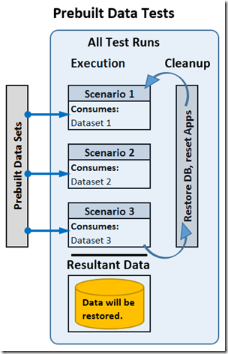

Self Feeding Data Tests
Self Feeding tests assume that some test items rely on previous items and therefore execute the previous items and capture the output of those tests to feed into the other tests. A good example of an application that would benefit from this type of testing is a hospital management app. The first part of the test allows someone to check into the hospital, do insurance, etc. The second part allows the nurses and doctors to help the patient. The third part allows the patient to be checked out and to file insurance. In this case, every part is dependent on the previous part to already be complete.
Self Feeding Data tests are designed in such a way that the tests create the data needed as they execute, allowing the tests to be used as a way of building extra data for the system so that you can watch the performance of a system as the size of data grows, and you can maintain the tests more easily since they create their own data. NOTE: These tests are often the most difficult to build up front because you have to add the ability to collect data during execution and save it for use by the test in future iterations, but they are the most realistic in terms of mimicking real world behavior.
The idea is that you generate one set of seed data, then you feed that into the first part of the test and execute it. That data then will get fed into the second part of the test while you use more seed data to generate the next set of data:
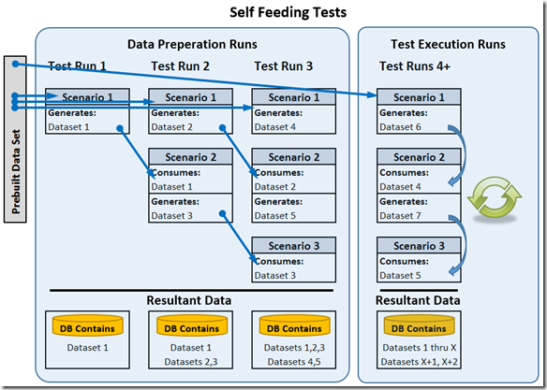

Reviewing The Plan
- Item

Sample Test Plans

Test Plan For Contoso eCommerce
- Item

Test Plan For River Bank
- Item

Proper Use Cases and Scenarios
As of this point, we should have well defined Goals, Objectives and success criteria and we should have an idea of how we want to consider building our data. Now we want to lay out the basic scenarios and use cases. Before we start this, I want to give you my definitions for “Scenario” and “Use Case”. I have two versions for each term. The first applies to how we work with them in our test planning and the second applies to how they are used inside Visual Studio.
Term | Scope | Definition
Scenario | Real World | (test plan) – A Scenario here defines a grouping of different tasks that a user may perform on the system. I often define a separate scenario for each type of user role that will be part of the test (a school application might define teachers and students as two different roles. Each role will get a separate scenario in my test plan).
Scenario | Visual Studio | (load test) – A logical grouping of tests and test settings in a Visual Studio Load Test that tells the test rig how to generate load.
Use Case | Real World | This is a certain task that a user will perform using the application.
Use Case | Visual Studio | (web test) – The specific commands in a web or unit test that mimic the steps a user performs when executing a task (Real World Use Case).

Example 1 – “School’s Back In Session”
For this example, I will use a web site that a school uses to manage the classes offered. I will focus on two user roles; TEACHERS and STUDENTS. This will allow me to define two different “scenarios” in my test plan. Then, for each scenario, I will look at the work that a user from each role might do. The work will be broken down into specific tasks, and each task will become a “use case”:
  - Teacher:
    - Login (I define this separately because I know it will be a test I want to perform so I get it out on the radar right away)
    - Enter grades for tests already taken
    - Submit updated homework assignments to public portal
  - Student:
    - Login
    - Look up test scores for current semester
    - Download the latest homework assignments from the public portal

Example 2 – “Are You Ready For Some Football?”
My apologies up front to all of the readers who know soccer as “football”. I love soccer, but in this case, I am partial to what Americans call football and am referring to NCAAF and the NFL. Anyway, it’s time to hit the gridiron and I want to make sure my site can handle the load. So for this example, I will focus on a site that hosts both fantasy football and real football information, sales and game updates.
  - Fantasy Football Fan:
    - Draft players onto the team
    - Check the stats for the players throughout the season
  - Real Football Fan:
    - Buy tickets for the game
    - Follow the game in real time on the site.

Building the Test Plan Items
Now that we have our scenarios and use cases, we can incorporate them into our test plan. As we fill in this information, keep in mind that the data I am providing here has NOTHING to do with Visual Studio or any other testing tool. I am merely laying out the expected real world behavior that I wish to mimic when testing.
Example 1 – Our GOAL for this testing (just to make things easy to follow) is to ensure that the site will be able to handle the expected load and perform within the expected criteria (see the Introduction post for more info if needed).
Scenario | Use Case | # users | # times per user per week | Notes
Teachers | Login | 150 | 5
Teachers | Enter grades | 150 | 5 | Assumes teacher has 5 classes, therefore, updates 1 test set per class per week.
Teachers | Update homework | 150 | 25 | Assumes teacher has 5 classes, therefore, updates all homework each day.
Students | Login | 3000 | 5
Students | Check grades | 3000 | 4 | Assumes student has 4 classes.
Students | Get new homework | 3000 | 20 | Assumes student has 4 classes.
Of course, your table will be much more detailed and may contain caveats or other requirements here, but the idea is that we defined our use cases and numbers based on “expected load” and using “real world” examples.
Example 2 – Our GOAL for this testing is to determine the breaking point of the application, therefore we use a slightly different table to define our scenarios and use cases. Since we are finding a breaking point, we do not know what the final real world user load will be. However, we should be able to at least have a ratio of the amount of users and actions relative to all of the other use cases involved.
Scenario | Use Case | # users relative to other use cases | # times per user per week | Notes
Fantasy | Draft | 100 | 0.1 | Draft only happens once per season, so this number is way low
Fantasy | Check Stats | 100 | 20
Real | Buy Tickets | 1 | 1
Real | Follow Game | 2000 | 180 | This assumes that the users update their page every minute of a 3 hour game.
In the above table, the “# users” column represents a ratio (or multiplier) that I will use to increase load. If I decide that there will be 50 people buying tickets, then I will have 50 x 2000 (or 100,000 people following the game online). Also, we might want to be able to change the load for the “Real” scenario without changing the load for the “Fantasy” scenario. If that is the case, then we should call that out in our test plan. This is another example of “getting all of the necessary information up front.”
NOTE: I could easily split the “Real” scenario into two scenarios if I wanted to, but I chose to make it simpler. It doesn’t affect the way I will approach building the harness.

Building the Load Profile
Here are some terms we will use in this section:
Term | Scope | Definition
User | Real World | A person who will use the system that is being tested.
vUser | Harness | A representation of a 'user' inside a testing tool (virtual user)
Iteration | Harness | An Iteration is a single vUser performing the entire steps of a single use case. At the end of the iteration, the vUser is ready to perform another iteration. The next iteration can be the same User or a different User (SEE NOTE BELOW FOR CLARIFICATION).
Work Load | General Term | The Work Load represents the total amount of work that a system is subject to. It is obtained by combining the number of users [real world] or vUsers [test harness] and the amount of work each user or vUser does during a certain timeframe.
Think Time | Harness | Think time is the amount of time a vUser waits between each step of a use case (web test).
Pacing | Harness | Pacing is the amount of time a vUser waits at the end of a test iteration before starting the next iteration.
NOTE about iterations. In the definition, I stated that “the next iteration can be the same USER or a different USER. The key item here is that the next iteration will always happen as the same vUser, but the real world user being simulated can be either a NEW user or a RETURN user. A NEW user is a person who has not already been on the site in question and therefore does not have any browser cache or session data/cookies available. A RETURN user has cache and session/cookie data.

Explanation of the difference between USERS and VUSERS
A USER is the “real world” person that is described in the use cases and scenarios used to create a test harness. The number of USERS, as well as their usage pattern is determined by analyzing real world numbers from production environments or from projected usage analysis and has nothing to do with the operation of a Visual Studio Load Test.
A VUSER is the set of resources that Visual Studio uses to simulate the work of one of the above users. The total number of VSERS is determined by understanding the maximum number of CONCURRENT TESTS that need to be executing and NOT by the total number of USERS that need to be simulated.
There are three ways I like to measure USER counts and each maps back to a VUSER differently:
  - Total USERS – This is the total number of UNIQUE people that use the system over the timeframe being measured. I use this number to determine how many rows of data and/or user accounts, etc. I will need to feed into the test harness. This value does not necessarily have any direct correlation to the number of VUSERS.
  - Total Sessions (Tests) – this represents the total number of times all of the users connect, do work and disconnect during the timeframe being measured. This number will always be as large as “Total USERS” and may be larger (if a given unique user goes to the web site 3 different times then the total users is 1, but the Total Sessions is 3). This value does not necessarily have any direct correlation to the number of VUSERS.
  - Maximum Concurrent Users – this represents the maximum number of sessions that can be concurrently connected and doing work. This value defines the number of VUSERS we need to have in our test mix.

Choosing the Proper Load Model
The load model in this case is the test mix option you choose inside a Visual Studio load test for the scenarios you create. For this post, I will focus on only two test mixes and show when and how I use each one. I will look at my Goals to determine which load model to use. After I choose the load model, I will figure out the numbers to use. Each model requires a different way of calculating the values to use. Below are the two test mixes I use, as well as the pros and cons of each:

Based on User Pace
  - Useful for modeling a known and consistent load against a system for the purpose of obtaining the application’s behavior at a given load.
  - Easy to create specific user rate
  - Load Test Scenarios may be more complex and require planning.

Based on total number of tests
  - Useful for driving load at various different rates (step loads) for the purpose of identifying bottlenecks and/or determining scalability limits.
  - Easy to create a maximum load.
  - Difficult to create and reproduce a very specific user rate.

Choosing the Proper Numbers

Based on User Pace
From our previous post, we have a plan for “School’s Back In Session” with some numbers. We want to see if the system can handle the expected load, so the “User Pace” option is perfect. I will have two scenarios, one for teachers and one for students. The table of values from the test plan is below. Notice that I have added an extra column (# timer per user per hour). I added this because I do not want to run my test for a week, so I need to “translate” the value. I assume a 40 hour work week.
Scenario | Use Case | # users | #/user/week | #/user/hour
Teachers | Login | 150 | 5 | 0.125
Teachers | Enter Grades | 150 | 5 | 0.125
Teachers | Update HW | 150 | 25 | 0.625
Students | Login | 3000 | 5 | 0.125
Students | Check Grades | 3000 | 4 | 0.1
Students | Get HW | 3000 | 20 | 0.5
From this table, we can see that the numbers don’t work. I cannot put fractional numbers into the test harness, so I need to do some more “translation.” I will first calculate the total number of iterations that have to occur for each use case, then I can divide that up in order to get a new set of values for “# vUsers” to use (in some cases I will need to round the numbers):
Scenario | Use Case | # users | #/user  /hour | ~ Total | # vUsers | #/vUser/hour
Teachers | Login | 150 | 0.125 | 19 | 19 | 1
Teachers | Enter Grades | 150 | 0.125 | 19 | 19 | 1
Teachers | Update HW | 150 | 0.625 | 94 | 19 | 6
Students | Login | 3000 | 0.125 | 375 | 75 | 5
Students | Check Grades | 3000 | 0.1 | 300 | 75 | 4
Students | Get HW | 3000 | 0.5 | 1500 | 75 | 20
We had to drastically change the number of vUsers we allocate for the test, but this isn’t a big concern as long as the load that the server has applied to it is similar to what we expect in the real world. In this case it is. (There are situations where the math is not this simple, and there are other calculations you should make to verify the accuracy of the load. I will cover these topics in the next post.)
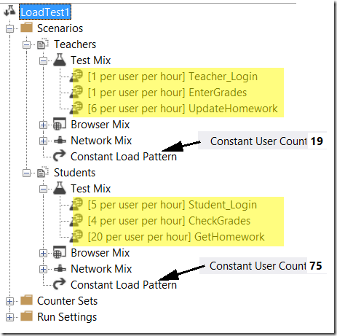

Based on total number of tests
For this example, let’s focus on “Are you ready for some football”. To recap, we wanted to find the breaking point of the system. Let’s review the numbers again. We do not define the TOTAL number of users. We define the ratio of users that perform a given task compared to the other task. Think of this as “For every person that buys a ticket, 100 people will play in a draft league, and 2000 people will follow the game online.” The next column is similar; “Each user will only buy one ticket for a game, but will check the status of the game 180 times during the 3 hour game window.
(Did you notice anything unusual about the last sentence? I used the word “week” to describe one value in the fourth column and “3 hour window” to describe another value. This is a great example of a place where reviewing the values before moving on is critical. I would immediately go back to the business partner and make sure that I understood what the real rate of work is, especially since you can imagine that the NFL website is MUCH busier on Sunday than any other day. Therefore, I didn’t calculate the values for the fifth column. I got the values for the fifth column by getting more info from the owners of the site.)
Scenario | Use Case | # users ratio | #/user/week | #/user/hour
Fantasy | Draft | 100 | 0.1 | 10
Fantasy | Stats | 100 | 20 | 10
Real | Tickets | 1 | 1 | 1
Real | follow game | 2000 | 180 | 60
Now I can build the model. First I will use percentages for the loads, so I need to translate the fifth column from a ratio to a percentage. I can choose to run all four use cases in one Visual Studio Scenario, or I can keep them split in two Visual Studio Scenarios. For the example, I will keep them split. This is a more complex way, but it helps me illustrate all of the considerations needed for modeling load.
The percentage for each of the two “Fantasy” use cases is 50%. The percentage for the “Real” Scenario is split up by taking 100 and dividing it by the total (61), then multiplying each Use Case’s ratio by the result and rounding: Tickets = 1.7, rounded to 2. Follow = 98.3 rounded to 98. For this load, I want to use a step load pattern to increase the load, so I define the scenarios to run with the percentages I just calculated, then I define the overall load by setting the number of vUsers to step through various quantities. Because I chose to keep the two scenarios separate, I need to account for the different volumes for each scenario. I have an average of 20 items for “Fantasy” compared to 61 for “Real” Therefore I will use a 1 to 3 ratio for the vUser counts in the test (This is the extra consideration I mentioned in the previous paragraph):
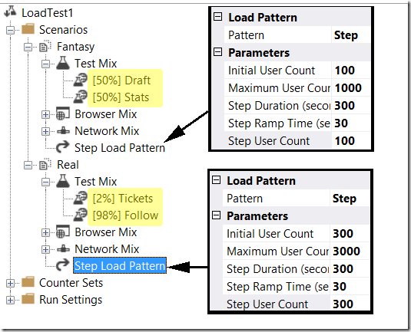

Additional Load Profile Considerations

Too Many Use Cases
This customer had defined eight different use cases to use for the load profile, but they provided FIVE sets of numbers to use for the loads on each use case. The five different sets of numbers represented five different business cycles in their industry and they felt that it was important to see if the system could handle the load expected in each of the cyclers:
Use Case | Profile 1 | Profile 2 | Profile 3 | Profile 4 | Profile 5
Read Only | 100 | 30 | 50 | 50 | 50
Active | 0 | 0 | 20 | 20 | 20
Generate | 120 | 50 | 60 | 60 | 60
Regenerate | 0 | 150 | 20 | 20 | 20
Sign Off | 0 | 0 | 50 | 200 | 50
Archive | 0 | 0 | 25 | 100 | 300
Modify | 2000 | 5000 | 4000 | 2000 | 2000
No Change | 2000 | 1500 | 4000 | 2000 | 2000
As we looked at the table, and we started adding up all of the different load tests we would need to execute, we realized that we would not have enough time to complete every one of the desired tests. When I looked at the numbers, I noticed that there wasn’t too much difference between the load in Profile 3 and other profiles except for the last two use cases. I suggested that we build a new profile that used the highest count from each use case and run that. If it passed our criteria, then we knew that all of the individual profiles would pass. We could do this because we were testing specifically to see “If the System can handle the expected peak load.” Below was our final profile. The system could handle this load, so we could easily assume that the system could handle any of the loads specified in the profiles above.
Use Case | Final Profile
Read Only | 100
Active | 20
Generate | 120
Regenerate | 150
Sign Off | 200
Archive | 300
Modify | 5000
No Change | 4000

Too Fast
I was brought into an engagement that was already in progress to help a customer who was trying to figure out why the system was so slow when we pushed the load to the “expected daily amount.” The system was taking as long as 120 seconds for some requests to respond and the maximum allowed time was 60 seconds. They said that they were used to seeing faster times when the system was not under load. I started asking them about the load profile and I learned two things that they had not done properly.
  - They were using the wrong type of load pattern to drive load. They had chosen to use the “Based on number of tests” pattern when they should be using the “based on user pace” pattern. By selecting the Based on number of tests, they were pushing the load harder than they should have (explanation below)
  - They were using the wrong numbers for the amount of work that an actual user would be expected to perform.
Because of these two items, the work load they were driving was about 6 times higher than expected peak load. No wonder the system was being slow. I showed them how to rework the numbers and we switched the test profile to user pace. When we ran the tests again, the system behaved exactly as it should.
Comparing “Number of Tests” to “User Pace”
The reason that using the “Based on the number of tests” (or “based on the number of virtual users” is NOT good when trying to drive a specific load is that Visual Studio will not throttle the speed of the tests. When a test iteration is completed in either of these modes, Visual Studio will wait for the amount of time defined by the “think time between test iterations” setting and then execute the next test it is assigned.. Now, if you assume that you know how long a given iteration of a test should take and you use that number to work backwards to a proper pace, you still may not get the right load. Consider this:
  - A given web test takes 2 minutes to complete.
  - You want to have that web test execute 12,000 times in an hour.
  - If you work it backwards, you would see that you could set the test to use 1,000 vUsers and set a “think time between test iterations” of 3 minutes.
This will give you the user pace you want….. Until you fire up those 1,000 users and realize one of two things that could cause the pace to be wrong:
  - the load slows down the test so that it takes 3 minutes. Now your pace is not 12,000/hour, but 10,000/hour.
  - the test is being run on a faster system (or something else causes the test to run faster, including performance tuning) and the time for an iteration is 1 minute. Your pace is now 15,000/hour.
If you set the model to “Based on User Pace” Visual Studio will ignore the “think time between test iterations” setting and will create the pacing on the fly. In this case, you set 1,000 vUsers and tell each one to do 12 iterations/hour. Visual Studio will target a total time of 5 minutes for each iteration, including the think time. If the iteration finished in less than five minutes, it will wait the right amount of time. If the iteration takes longer than 5 minutes Visual Studio will throw a warning and run the next iteration with no think time between iterations.

Need to use multiple scenarios
Sometimes when you look at the rate that one test needs to execute compared to another test, you may find that you cannot have both tests in the same scenario. For instance if you have one test that needs to run once/hour and another that needs to run 120/hour, but the 120/hour takes 2 minutes to complete. You can no longer run that test with a single user . So you decide to decrease the rate to 30/user/hour and then increase the total number of users to 4. Now, the other test is running at four times the rate. For situations like this, I simply move the tests into two separate scenarios.
You may also find that you have too many tests in a scenario that has “Based on User Pace” to allow a user to complete them all. When you specify the User Pace model, Visual Studio will expect that a single vUser will execute EVERY test in the scenario at the pace defined. Let’s go back to the school test from the previous post. If you look at the scenario for Students, you will see that there are 75 vUsers. Each vUser will have to complete 29 test iterations in an hour to stay on track. Visual Studio does not create separate users for each webtest. Therefore you need to make sure that there is enough time for all of the tests to complete. If not, split them up into separate scenarios.
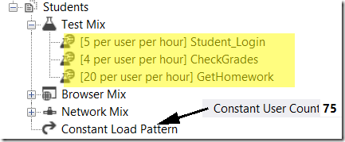

Don’t Count It Twice
This one bites a lot of people. Let’s say I am testing my ecommerce site and I need to drive load as follows:
Use Case | Qty to execute
Browse Site | 10,000
Add To Cart | 3,000
Checkout | 2,000
So you create your three tests and set the pacing up for each. However, you need to remember that *usually* in order to checkout, you have to already have something in the cart, and to add something to the cart, you have to have browsed. If you use the quantities above, you will end up with 15,000 browse requests to the site and 5,000 Add to Cart.
Bottom Line, if a test you execute contains requests that fulfill more than one of your target load numbers, account for that in the final mix.

Multiple Acceptance Criteria for the Same Item
This is in response to a comment left on my previous post about Scenarios and Use Cases. In this situation, I may have a requirement for the response time for generating a report. Let’s assume that the requirements are:
  - Generation of the report must be < 2 seconds for <500 rows
  - Generation of the report must be < 7 seconds for <10,000 rows
First, I would need to get more info from the business partners.
  - Is the user type the primary reason for the big size difference? (a sales clerk checks the sales he/she has performed today vs. a store manager checking all of the sales by the entire staff?).
    - I would add a new use case to the manager scenario and a separate use case in the sales scenario of the test plan and move forward as normal.
  - Is a parameter passed in, or the query being executed the primary reason (same as the first example, but the same person runs both reports)
    - I would ask the business partner what the likelihood of either happening is and then I would devise a set of data to feed into the test that would return results close to each number. I would probably then create two different web tests, one for each query set and give them names that indicate the relative size of the response. Then I could easily see how long each one took.
It is also worth noting that you can have the same request show up multiple times in a webtest and change the way it gets reported by using the “Reporting Name” property on the request to display the relative size:
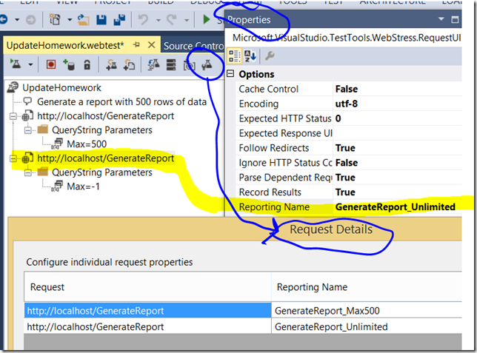

To Think or not To Think
- This is one of my favorite topics to debate with people, and it also seems to be one that stirs up the most passion amongst testers who have an opinion. However, as with so much information in testing strategies, there is NOT ONE CORRECT ANSWER.
What I hear all the time…
“Driving load without introducing think time in your test harness is a great way [the best way] [the only way] [place your phrase here] to push the system and find the breaking point and/or capacity of an application”

Example 1 – Bad for the System
For this example, I was helping a customer test their application, attempting to reach a throughput of 24,000 transactions in an hour. Given the estimated speed of each transaction, they had estimated that a single user could process a single transaction in about 15 seconds. This translated to 240 transactions per user per hour without think time. Therefore they configured the test to run for one hour with 100 concurrent users. They got fairly close to reaching the goal of 24,000 and seemed pretty happy. However, I had a nagging feeling about these results, so I suggested that we modify the load test to run on User Pacing, instead of Number of Users. By switching, we were telling Visual Studio to drive load toward a pre-defined pace instead of “as fast as you can go.” I decided to set the pace to be 48 transactions/user/hour with a user load of 500. This would supposedly show the same behavior:
  - 100 users X 240 transactions/user/hour = 24,000 transactions per hour
  - 500 users X 48 transactions/user/hour = 24,000 transactions per hour
So naturally, we would get the same (or at least similar) results… We hit the “Execute” button, and watched over the next five minutes as the system proceeded to fall apart completely. By the time I hit the abort button, we were on pace to complete less than 5,000 transactions in an hour…. It turns out that they had a couple of components in their front end server software that built and managed their own thread pool. Every user hitting the system was spinning up 8 different threads to do work. When we switched to 500 users, the system was overloaded with blocking, deadlocks and resource starvation. We never would have caught that with only the initial testing.

Example 2 – Bad for the Rig
For this example, we were trying to max out a WCF connection module. We wanted to measure how many users could be authenticated in a given time frame. In my mind, this was a reasonable test to try running without think time. The test created a connection, then released it. This was executed with a step load up to 5,000 users and no think time or pacing. The test was executed twice, and both times the test aborted itself just before reaching the desired load of 5,000 users. The reason was because of an "Out of memory" exception on the test agent machine. The agent was sustaining 97-100% CPU, context switching of over 100,000/sec, a Processor Queue Length averaging 137/sec and maxing at over 500/sec.
This extra work was brought about on the agent because the test being executed was a very short and fast test (the average total test time was 0.006 seconds). The agent machine had to do more work per test than the system being tested. Therefore, the agent machine would never be able to keep up. We added a one second pacing time to the load test, and immediately the test rig started behaving better. We went down to an average Context Switching rate of 8,000/sec and an average Processor Queue Length of 0 with a max of 4. Our CPU dropped to around 85% on the agent. We added 4 more agents and were able to drive a sustained load of over 4,800 tests/sec with 5,000 users.

Conclusion
When trying to test the capability of a certain part of a system, people often build and execute load tests with no think time in the tests and drive the load "as fast as they can." This approach does have value in certain instances, such as Red Zone, Green Zone testing of SharePoint Servers (http://technet.microsoft.com/en-us/library/ff758657.aspx) or testing failure points on systems where you wish to find or reproduce blocking/race conditions. However, when doing this type of testing, you need to be aware of how the results can be used, how the profile can hide potential issue in the Application being tested, and what effect the test has on the rig providing the load.

Prepare

Scenarios
- Item

Use Cases
- Item

Load Profiles
- Item

Data; Start Creating
- Item

Harness Creation
- Item

Application, Environment and Rig Preparation
- Item

Final Test Plan Review
- Item

Updated Samples

Preparation For Contoso eCommerce
- Item

Preparation For River Bank
- Item

Execute

Mission Control (The Work Room)
- The setup, requirements and necessary supplies
- Day 1

“Fire in the Hole!” (Test Execution and Analysis)
- TORs, Smoke Tests, Break/Fix, and etc.
- Determining

“Pack ‘em, Stack ‘em and Rack ‘em” (Data collection and retention)
- What data to keep
- How to organize

“Medic!”(Finding and Fixing)
- Finding Issues
- Determining which fixes to try
- Coordinating fixes with the development teams

“Focus Bueller!” (Avoiding Scope Creep)

The Daily Standup
- Controlling the flow of the project and keeping the train on track
- How to deal with conflicts and scope creep

The High Level List
- Keeping the list of goals and objectives readily visible.
- Changing the direction of the engagement in mid-stream

Sample Executions

Executing On Contoso eCommerce
- Item

Executing On River Bank
- Item

Report

The Summary Report
- Getting information from the SMEs
- Getting information from the system
- Tying it all together
- Making it readable to all levels of management

Closing the feedback loop
- Reviewing the lessons learned
- Post-execution action items
- Following up with the rest of the IT organization

Sample Reports

Reporting On Contoso eCommerce
- Item

Reporting On River Bank
- Item

Part 2 – The Tools

Visual Studio Web and Load Testing Tools

Test Rigs and Test Harnesses
When talking about load and load performance testing, you should split the testing tool portion into two main categories:
- The Test Rig – This is the hardware hosting Visual Studio (or the other testing tools), as well as the Visual Studio load testing application (or other testing application).
- The Test Harness – This is the suite of tests (in Visual Studio, it is the solution you create) that will be executed on the test rig.

Visual Studio Test Rig
A Visual Studio Test Rig consists of four major software components:
Component | Executable Name | Description
IDE | Devenv.exe | This is the copy of Visual Studio Enterprise that you will use the create, execute and analyze the tests.
Controller | Qtcontroller.exe | This is a service that manages test execution, collects perfmon data from the SUT, writes results to the database
Agent | QTAgent.exe | This is a service that performs the actual test execution
 | QTAgent32.exe | This is the 32-bit version of qtagent.exe
 | QTAgent_XX.exe | This is a version of qtagent.exe built with the XX version of the .NET Framework.
 | QTAgent32_XX.exe | This is the 32-bit version of qtagent_XX.exe
 | QTDCAgent.exe | This is the service that acts as a Data Collector agent
 | QTDCAgent32.exe | This is the 32-bit version of qtdcagent.exe
Database | SQL or SQL Express | LoadTest2010 database where results are stored

The software components reside on one or more machines (the hardware components). The diagram below shows a typical large scale rig and the communication that occurs between the components:
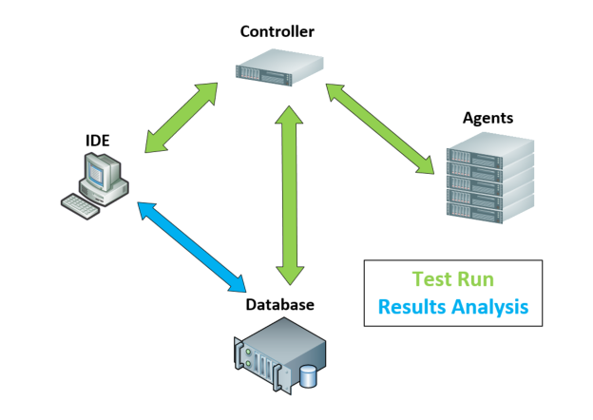

The diagram below shows the various communications ports and user information needed for the software components to communicate with each other:
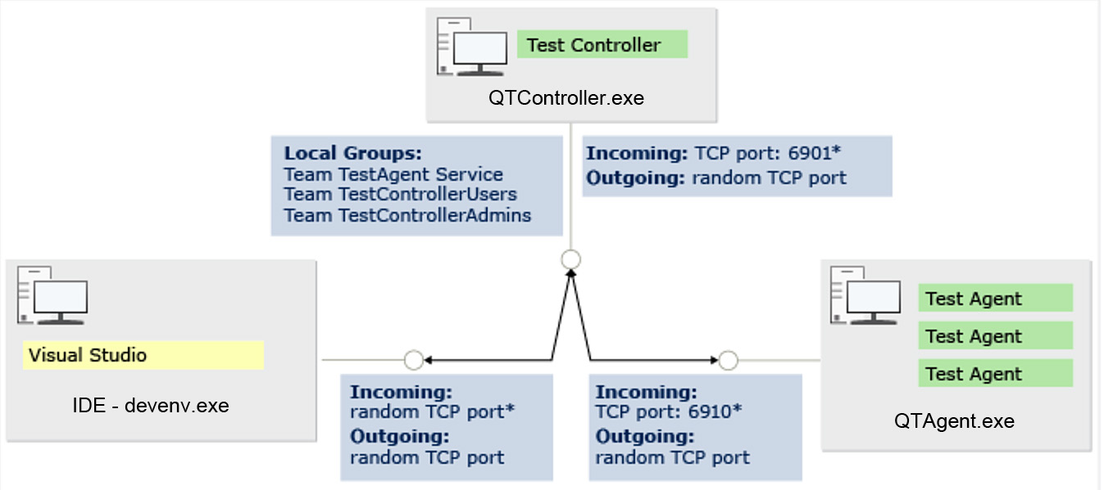

Visual Studio Solutions and Projects
Visual Studio stores the code and other objects for your work in “Solutions.” Each Solution will contain one or more “projects” and may also contain extra files that are not associated with a specific project.
A Visual Studio project is a grouping of files and settings that are all a part of a single portion of a given application.
Analogy: Think of a solution in terms of a book:
- The book is the solution
- Each chapter in a book is a separate project.
- Each chapter will contain
  - text (your source files)
  - graphics/images (your bitmaps or other graphical files)
  - tables of data (your data files, etc)
  - links or pointers to other parts of the book (e.g. “See chapter 6 for more details on…”). These are the “References” in a project.
- The book will also contain TOCs, Indexes, Bibliographies and etc. are all the separate “solution items” that are not a part of a given project.

Visual Studio Test Harness
A test harness consists of a Visual Studio solution containing at least one “Web Performance and Load Test” project and any supplemental artifacts needed to support that project.
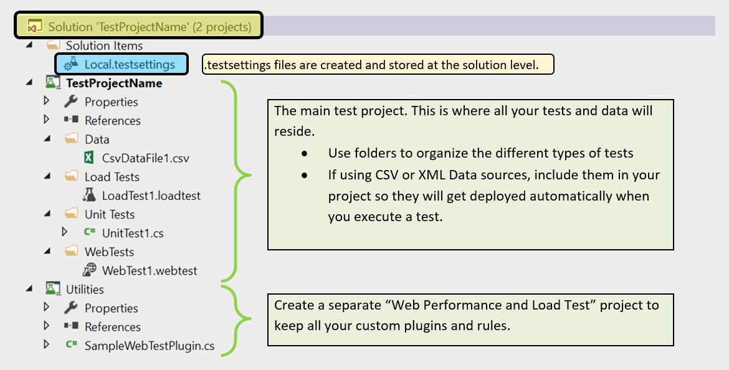

Web Test Information
Xxx

Creating a new webtest
xxx

Recording
Xxx

Initial Cleanup
Xxx

Troubleshooting a Webtest
Xxx

Using the Recorded Results playback
When you record a Webtest in Visual Studio, it saves a copy of the initial results in a file located in the folder where you created the Webtest. The name of this file is webtestname.{GUID}.rec.webtestresult. This file is NOT included in the test project. As long as this recorded result is available, you can access it by either directly opening it from File Explorer or by clicking on the “Recorded Result” button in the playback window for the Webtest:
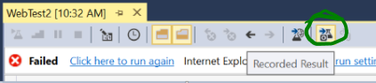
You will often find yourself going back to this recorded result for troubleshooting.

Fixing “Request failed: Context parameter 'XXXXX' not found in test context” error
When you run a Webtest and get an error in the ‘Web Browser” tab of the results window that starts off with “Request failed: Context parameter…” this indicates that the test never sent the request because a context parameter needed for binding to a value was not available:
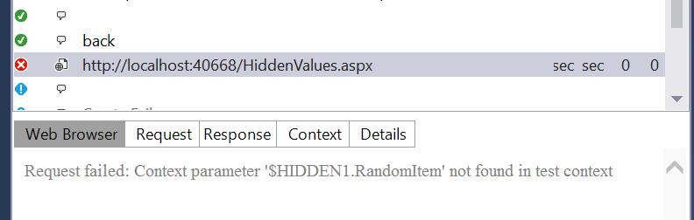

In the next picture, you can see the list of context parameters that were available (on the left hand side). The context we need is missing.
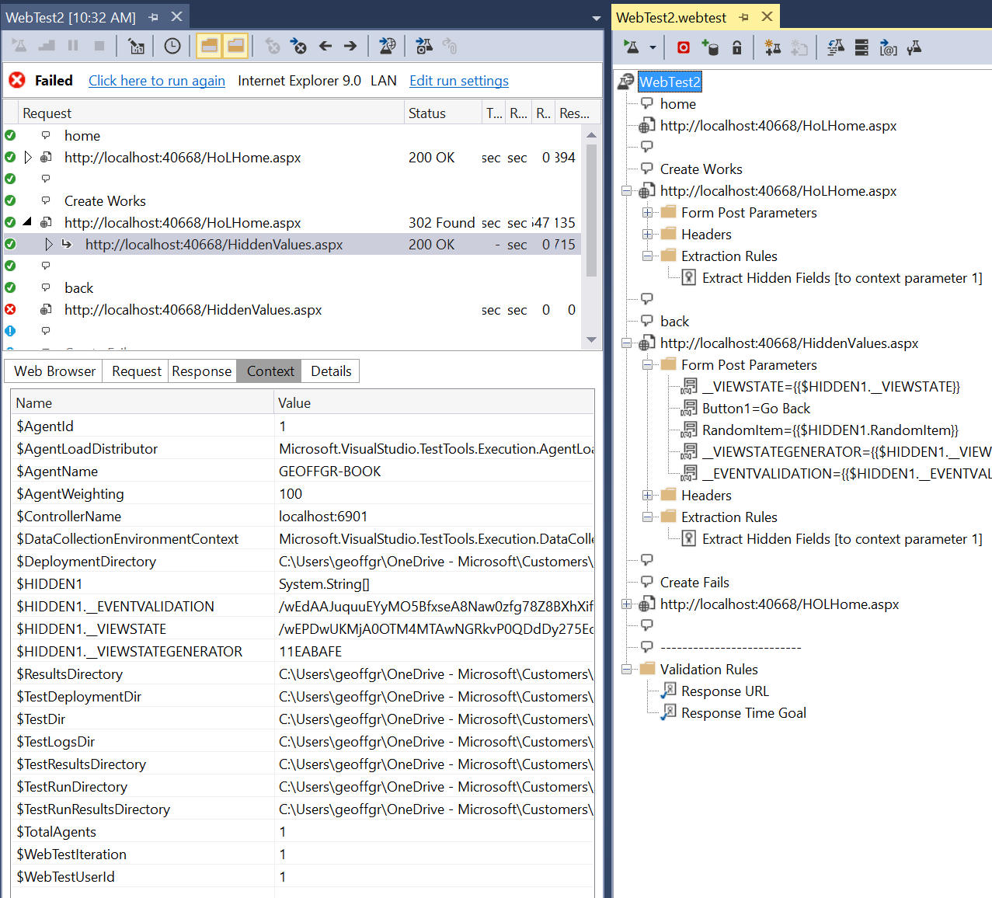
In order to troubleshoot this type of issue, you need to look up in the playback to the request where the context parameter was supposed to be extracted. In the case of Hidden Parameters, you should look for the “Extract Hidden Fields” rule with the appropriate index (in the above example, it would be context parameter 1):
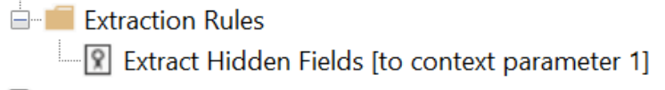

Once you find the request, compare the Request values for the failed iteration to the Request values in the “Using the Recorded Results playback” version to see what may be different:
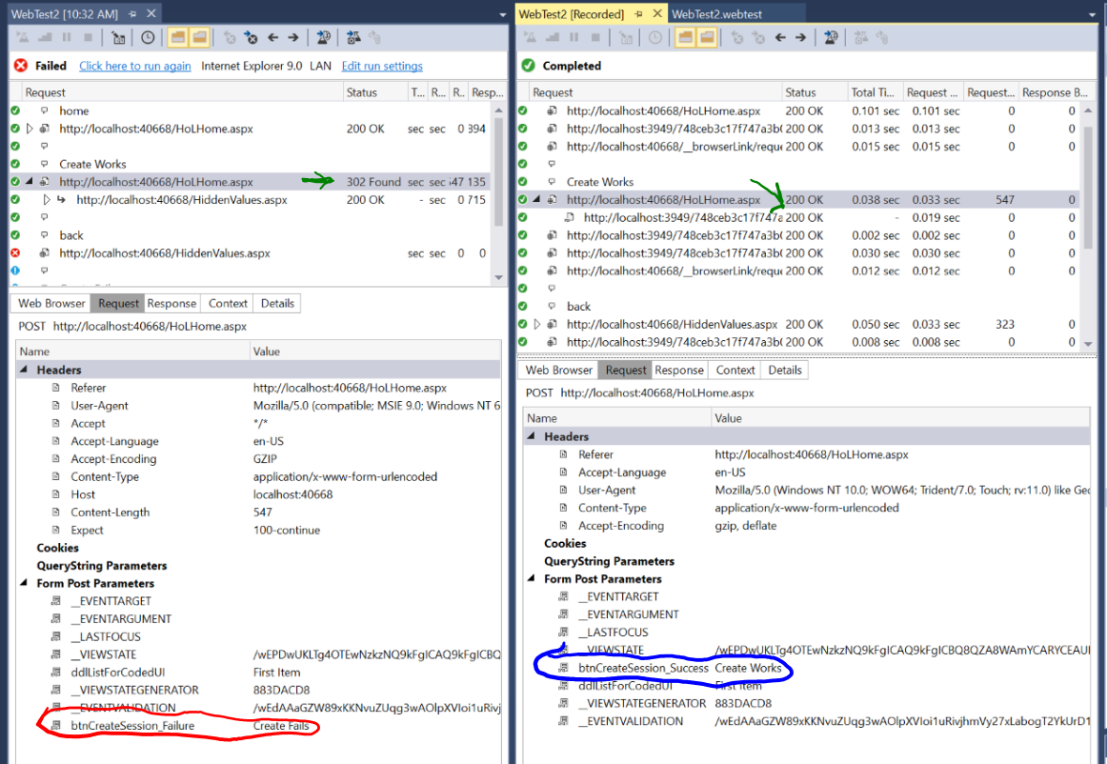
We can see that there is a Form Post item we sent in the failed playback is different in the recorded result. This is the first place to try to fix the issue.
NOTE: Many times, the issue is more complicated than simply finding a different form post item. This is where having access to one of the web application developers is critical for working through the issue. My example above uses fairly obvious names, but you will normally not get that. You would need to have the developer look at the code and determine why the missing hidden field would not have gotten populated.

Fixing Broken Dynamic Parameters:
(Example Material taken from https://msdn.microsoft.com/en-us/library/ff460245.aspx)
This example shows how to troubleshoot and fix dynamic parameters that Visual Studio’s recorder may have missed or improperly detected.

Suggestions for maintaining readable and usable Declarative Webtests
xxx

Suggested Commenting and Transaction Timer usage in Visual Studio webtests
The need for proper commenting and request grouping is not only underutilized by most webtest authors, but the value of commenting is vastly misunderstood. Simple comments and usage of naming conventions will allow the testers and the people reviewing the results to have a much clearer understanding of what the test is doing. The tricks below are geared to set a process and structure that can be used over and over. (NOTE: Add info here about the accompanying utilities)
- Wrap EVERY user step in a transaction. Regardless of whether the user step has only a single request or multiple requests, each should have a transaction timer around it. Advantages:
  - Gives a full picture of the USER steps involved in the webtest.
  - Allows the user steps to be grouped in the load test results.
  - Allows for collapsing of the notes and requests inside the transaction which makes the view of the webtest itself much more readable.
  - The Power Pack uses these transactions to build a Use Case document for the harness.
- Put a blank comment between every transaction. (NOTE: This step is not necessary if you used blank comments in your recording steps. See Recording for more information) This makes reading the test at a glance much easier since the test is now broken up based on the user steps.
  - Transaction names have a numeric prefix. Start with the webtest’s prefix and then add a 2 digit number and an underscore followed by the transaction’s name (01_01_MyfirstTransaction). This makes following results of load tests based on the use cases and workflow much easier. (NOTE: Cross reference the example at the bottom of the “collapsed View” entry.)
- [if needed] Add a set of comments to the top of the test. Explain any overall notes in this section so it is easy for future viewers to know what is happening and any things to be aware of.

EXAMPLE - The Importance of good commenting in web tests
The below picture shows how using good commenting practices makes reading the test much easier. (NOTE: Make this a sidebar picture that can be referenced easily from the “Suggested commenting” section.)
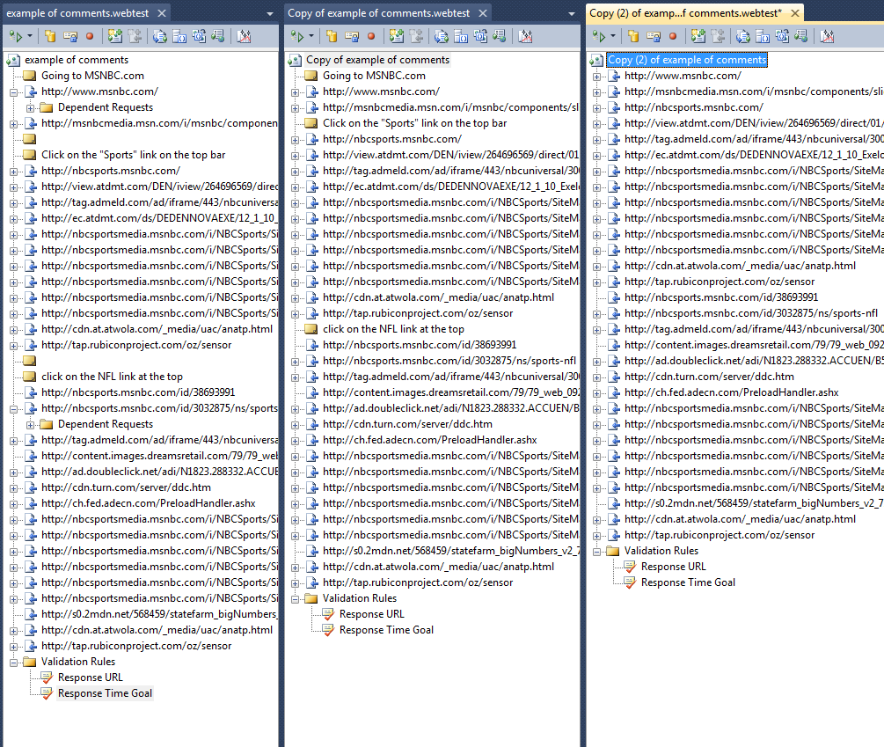
Without the blank comments, we can still reference the beginning of each request, and you still get the benefit of knowing what action was taken, but you must locate the comments without the benefit of blank spaces.
Here the comments tell us what we did and which requests are directly tied to a single action. By using blank comments, it is easy to see the three requests we made.

No explanation required. All I can say is "good luck figuring this one out."

Collapsed View
Use prefixes for test names and transaction names. Here I use XX_ for the test and XX_YY_ for the request. This allows the results of tests to be read in order of execution.
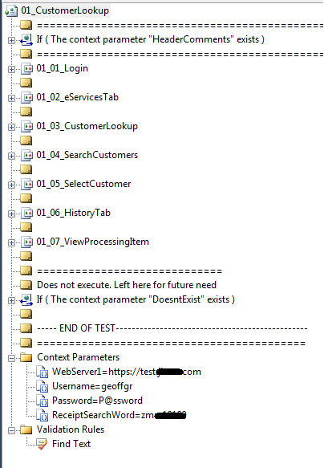
I wrap all requests that are a part of a single user action in a transaction, EVEN if there is only one request. This helps keep the test clean (since you can collapse sections) and it allows for easy analysis of the step results of a use case.
I had a number of requests recorded that might be helpful later on with modifying the harness, but that I do not want to have executing normally. I use the same technique as above to deal with it.
Build a header section for comments (Use Power Pack to automate). Wrap all of the comments in an “If” statement to allow collapsing the section. Use the context param “HeaderComments” to define what it is and to ensure the statement never fires. This will NOT impact any test results or performance.
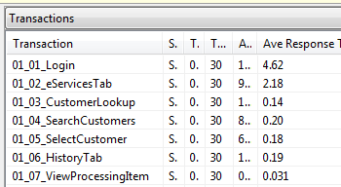
From the “tables” view of a completed Load Test

Use of comments within actual requests
This includes documenting dynamic portions and info about how the request may behave. I use a structured list of comment styles that clarifies the request set(NOTE: Add info here about the accompanying utilities):
I document dynamic contexts with a comment that has 5 spaces, then 5 asterisks, then a note of the item in question. Any reference to a context parameter uses the actual name and is enclosed in double curly braces. The terms I use are:
    - Extraction rule is used to get a value:
***** EXTRACTS {{...}} [-random]
    - Custom Plugin is used to get a value:
***** GETS {{...}} from <PLUGIN>
    - DataSource is used to get a value:
***** GETS {{...}} from <DATASOURCE>
    - A plugin is used to generate a value:
***** GENERATES {{...}} from <PLUGIN>
    - A context parameter is used in the request:
***** USES {{...}}
    - A Web Test Plugin is used in the test:
***** IMPLEMENTSS “...” PLUGIN
    - A Web Test Plugin is used in the test to bind a datasource:
***** IMPLEMENTSS “...” PLUGIN INTO {{...}}
I also use the following structure for other types of comments. Please NOTE that the MTSL Power Pack will perform certain actions based on comment types and it uses this format to identify the comment types:
    - Request notes of expected responses/behavior/etc
## Expected: blah
    - Request notes of issues to be aware of
!! WARNING: some note here
    - Request notes of bugs to be aware of
!! BUG: some note here
    - Request notes of uncommon behaviors to be aware of
%% INFORMATION: some note here
    - Request notes of a general nature
$$ NOTE: some note here (like use this whenever we add a ResponseBufferSizeLimit).
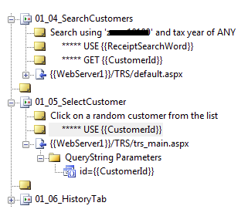
Use a blank comment between every step in the use case.
Put comments stating where you get context params and where you use them. I do not include the use of HIDDEN context params, but you may wish to.

Web Test Settings to Remember
“Parameterize Web Servers” button.
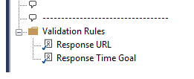
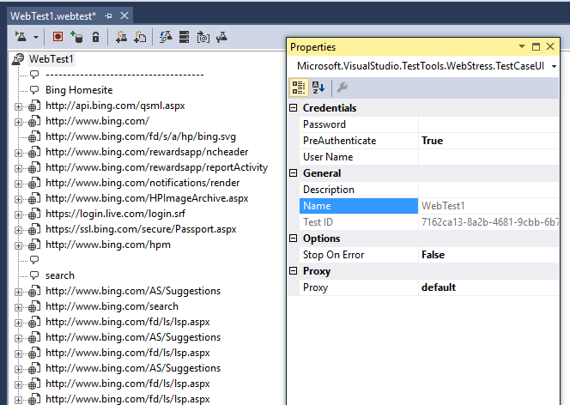
Change this from True to False
Change this from False to True

These two rules are added by default. Remove them from each test you create.

Checklist: Cleaning up initial webtest
- Rename the web test. Use proper naming conventions.
- Remove the two default validation rules (“Response Time Goal”, “Response URL”)
- Set “Stop on Error” to TRUE
- Set “PreAuthenticate” to FALSE
- Look for any comments made during the recording that require some sort of cleanup. Act on these.
- Wrap every user step (set or requests between blank comments) in a transaction. Use proper naming conventions.
- Parameterize the web servers – NOTE: Visual Studio gives default names which are useful, but you need to remember that the names may not always be the same between web tests. Define a naming scheme at the beginning of the project and make sure the names line up in every test. This will allow you to properly use the parameters in load tests and ensure they carry through.

Request Settings to Remember

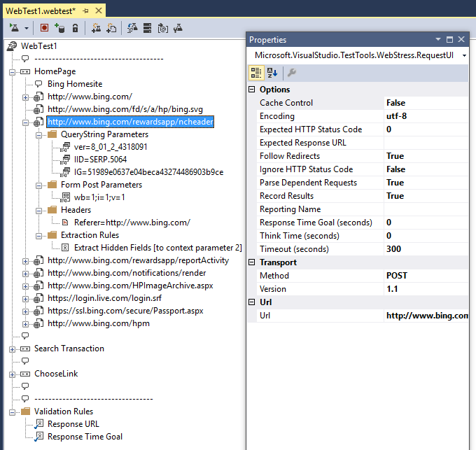
Reporting Names can be very useful whenmaking SOAP calls where the URL is the same for multiple methods. The results will show the requests by the reporting name

Declarative Webtest Architecture
The following shows the objects that make up a Declarative Webtest:

Webtest

Execution Objects
These items make up the collection of user steps and/or the “use case” for the test
  - Comment – Does not impact test execution. See the section on Suggested Commenting and Transaction Timer usage in Visual Studio webtests for more information.
  - Request – An HTTP request and all of the properties that indicate the way to execute the call and handle responses. See the section on Webtest Request for more information.
  - Conditional/Loop – An object that either:
    - Condition: checks for the defined condition and, if met, executes the series of objects contained inside the condition’s item collection.
    - Loop: executes the objects contained inside the loop’s item collection as many times as the loop settings dictate.
  - Transactional Timer – A named timer that will group execution time for all of the objects inside the Timer’s item collection.
  - Embedded Webtest – This object is a complete webtest that gets called when the parent webtest reaches it and is executed in its entirety before control returns to the parent webtest.

Property Collections
These items are used by the webtest in support of the Execution Objects
  - Data Sources – One or more references to a set of data that is available for the webtest to use during execution. Currently supported formats are: SQL Database, CSV and XML
  - Context Parameters – These are predefined variables that can be used by the webtest during execution. NOTE: Many context parameters will get created as part of the webtest execution, through extraction rules, plugins and data sources. This is important to remember since there are several ways to control test execution using the values of contexts in the context parameter collection and even on the existence of contexts inside the collection.
  - Webtest Validation Rules – Validation rules use a defined algorithm against a response from a webtest request and then return whether the the rule passed or failed. When a validation rule is added at the webtest level, it will execute for every request in the webtest. See the section on Validation Rules for more information.
  - Webtest Plugins – Extensibility points for execution. See the section on Webtest Plugins for more information.

Properties
These properties are used by the webtest in support of the Execution Objects
  - Stop On Error – If True, will cause the current iteration of a webtest to stop execution whenever a request fails due to an error or failure of a validation rule, required extraction rule or other plugin that sets a request to a failed state.
  - PreAuthenticate – Set this to false to allow the webtest to simulate the normal behavior of most browsers when starting a new session. This will cause the webtest to send the initial request to the server as “anonymous” and thus allow the server and the Visual Studio agent to negotiate the appropriate authentication protocol.
  - Username – The value that requests will use as the Name property for establishing an authenticated connection to the server.
  - Password - The value that requests will use as the Password property for establishing an authenticated connection to the server.
  - Proxy – the name of the proxy server to use if it is different than the proxy server defined in your default browser’s proxy settings. To use the settings from your browser, set the value for thois property to “default”.
  - Name – (Not Editable) This is the name of the webtest.
  - Test ID – (Not Editable) This is an internal ID that Visual Studio uses to manage all of the webtests in any project/solution.
  - Description – A string that gets stored in test results. You can use this to offer a better description of the purpose of the webtest.

Webtest Request

Child Objects
  - Dependent Request
  - Query String Parameters
  - Headers
  - Form Post Parameters
  - String Body
  - Binary Body
  - Extraction Rules
  - Request Validation Rules
  - Request Plugins

Properties
  - Cache Control
  - Encoding
  - Expected HTTP Status Code
  - Follow Redirects
  - Ignore HTTP Status Code
  - Parse Dependent Requests
  - Record Results
  - Reporting Name
  - Response Time Goal
  - Think Time (seconds)
  - Timeout (seconds)
  - Method
  - Version
  - Url

Transaction Timer
A Transaction timer is a container that allows you to group a series of Execution Objects together to track a cumulative time for the execution of all of the objects. When used during a load test, the results include two different times. The first is the total amount of time spent getting request response times AND all associated think times. This result is called the “Transaction Time.” The second is the total amount of response times WITHOUT think times. This result is called the “Response Time.”

Properties
- Name – The name that will be used in the results when reporting the amount of time.

Comment
A comment object is a string that shows up in the webtest and also in the playback results. For information on how to make test editing much easier, see the section on Suggested Commenting and Transaction Timer usage in Visual Studio webtests.

Properties
- Comment Text – The string of text displayed in the webtest and the playback window.

Conditional/Loop
A conditional or loop is a container that allows you to group a series of Execution Objects together and then set a condition to either execute in a loop or to possibly prevent execution altogether. When the webtest engine encounters a loop or condition, it evaluates the object (based on which rule was chosen) and sets a flag for “Condition Met” or “Condition Not Met.” If the flag is “Condition Not Met” then all the items inside the container will be completely ignored. The conditions are explained below.

Built-in Rules
- Conditional
  - Context Parameter Exists: The engine checks for the existence of the named context parameter. If the parameter is in the context collection, then the items inside the conditional will get executed. The value of the context parameter does not matter.
  - Cookie Exists: The engine checks for the existence of the named cookie. If the cookie is in the header collection, then the items inside the conditional will get executed. The value of the cookie does not matter.
  - Cookie Value Comparison: The engine checks for the existence of the named cookie. If the cookie is in the header collection, the value in the cookie will be compared against the provided value, using the provided comparison traits (such as “ignore case,” etc.). If the two values match, then the items inside the conditional will get executed. The value of the cookie does not matter.
  - Last Request Outcome: The engine checks the last request’s result for “Pass” or “Fail” and then compares it to the chosen property to determine whether to execute the items inside the conditional.
  - Last Response Code: The engine check’s the HTTP status code for the previous response and compares it to the HTTP Status code chosen in the conditional. If the values match, then the items inside the conditional will get executed.
  - Number Comparison:
  - Probability Rule:
  - String Comparison:
- Loop
  - Context Parameter Exists:
  - Cookie Exists:
  - Cookie Value Comparison:
  - For Loop:
  - Number Comparison:
  - Probability Rule:
  - String Comparison:

Included Webtest

Plugins and Rules
Visual Studio provides two different mechanisms for extending and customizing webtest execution; plugins and rules. Under the covers, they are very similar to each other. They all provide event handlers that you can use to read results, modify context parameters, change test behavior, etc. The primary difference is that the Rules all provide specific features and expose specific properties for extraction, validation and conditions, whereas Plugins simply provide the event hooks. They are somewhat interchangeable; you can write a validation rule inside the post-request event hook of a request plugin, so either one would work. The next few sections will explain each of the available rule/plugin templates.

Validation Rules
The following table <fill in here>
Inherits From | ValidationRule
Event Handler | Validate(object sender, ValidationEventArgs e)
Property to set | e.IsValid = true/false

Extraction Rules
The following table <fill in here>
Inherits From | ExtractionRule
Event Handler | Extract(object sender, ExtractionEventArgs e)
Property to set | e. Success = true/false
Add extracted value | e.WebTest.Context.Add(this.ContextParameterName, extractedValue);

Conditional Rules

Webtest Plugins

Webtest Request Plugins

Webtest Execution

Steps in a test
Below is a sample webtest and the results from the initial playback of the webtest. I have added a custom plugin for each of the plugin events that are available to a webtest (see the section on Plugins and Rules for more information). This will help show how a webtest is executed and how you can properly use all of the available actions to make your webtests very robust and dynamic.
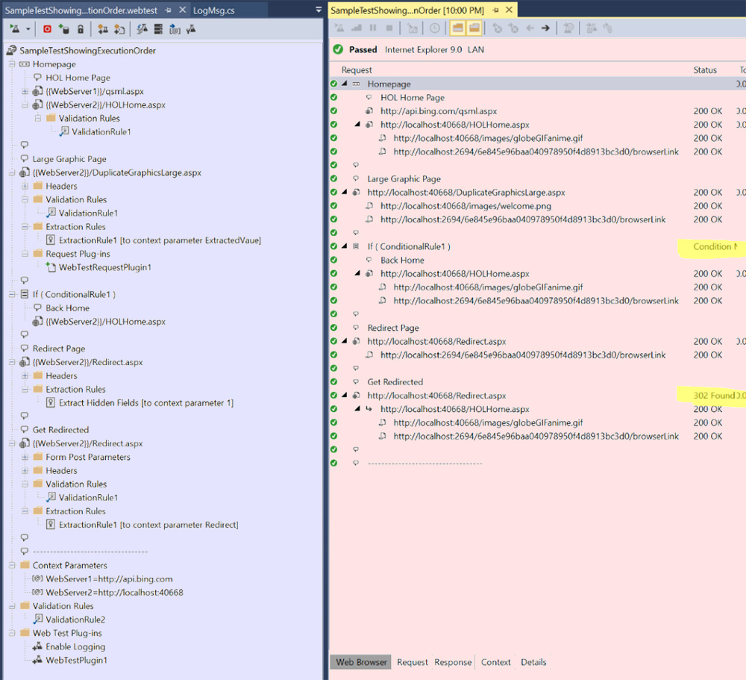
The list below shows all the basic steps used when executing a webtest. The following legend shows how to interpret the line items in the sample:
- -----Execution Step----- - this is a way of grouping a single item in a Declarative Webtest to the step(s) that are executed in the playback engine. There is one execution step for each of the Execution Objects in the webtest.
- <item> - an object from the Declarative webtest. There is one entry for each line in the webtest above
- [###] Custom event methods added to the webtest (ignore the number in the brackets for now. It is the thread ID for the thread used to execute the rule). The bold part shows what event was handled. The part after the bold shows the current value of the indicated property.
- [ENGINE] - execution steps handled by the playback engine.
- [RESULTS] – Item that was executed by the playback engine, but was not a part of the original webtest.

<WEBTEST>: SampleTestShowingExecutionOrder
[ENGINE] Webtest loaded into execution engine and parsed into the collection of objects described in the section Webtest
[ENGINE] Creates instances of all custom rules and plugins, WebTestPlugin_EnableLogging, which does NOT register for any events. The purpose of this plugin is solely to initialize the global logging flags used to collect the output for this document.
[018] WebTestPlugin1_PreWebTest – SampleTestShowingExecutionOrder
-----Execution Step-----
<TRANSACTION>: Homepage
[ENGINE] Transaction Timer Started
-----Execution Step-----
< COMMENT>: HOL Home Page
[ENGINE] Comment shown in playback window
-----Execution Step-----
[018] WebTestPlugin1_PreTransaction - transaction: Homepage
[018] WebTestPlugin1_PreRequestDataBinding - Request.Url: {{WebServer1}}/qsml.aspx
[ENGINE] Context Parameters in request object are populated with their current values.
[018] WebTestPlugin1_PrePage - page: http://api.bing.com/qsml.aspx
[018] WebTestPlugin1_PreRequest - Request.Url: http://api.bing.com/qsml.aspx
<REQUEST>: {{WebServer1}}/qsml.aspx
[ENGINE] Request executed
[ENGINE] Results parsed for dependent requests and redirects. These are executed unless overridden by custom code
[RESULTS] Dependent Request - http://localhost:40668/images/globeGIFanime.gif
[RESULTS] Dependent Request - http://localhost:2600/7169e3948f82438aa685af364e52da76/browserLink
[009] ValidationRule2_Validate - Request.Url: http://api.bing.com/qsml.aspx
[009] WebTestPlugin1_PostRequest - Request.Url: http://api.bing.com/qsml.aspx
[009] WebTestPlugin1_PostPage - page: http://api.bing.com/qsml.aspx
-----Execution Step-----
[009] WebTestPlugin1_PreRequestDataBinding - Request.Url: {{WebServer2}}/HOLHome.aspx
[ENGINE] Context Parameters in request object are populated with their current values.
[009] WebTestPlugin1_PrePage - page: http://localhost:40668/HOLHome.aspx
[009] WebTestPlugin1_PreRequest - Request.Url: http://localhost:40668/HOLHome.aspx
<REQUEST>: {{WebServer1}}/HOLHome.aspx
[ENGINE] Request executed
[ENGINE] Results parsed for dependent requests and redirects. These are executed unless overridden by custom code
[022] WebTestPlugin1_PostRequest - Request.Url: http://localhost:40668/HOLHome.aspx
[RESULTS] Dependent Request - http://localhost:40668/images/globeGIFanime.gif
[RESULTS] Dependent Request - http://localhost:2600/7169e3948f82438aa685af364e52da76/browserLink
[022] ValidationRule2_Validate - Request.Url: http://localhost:40668/HOLHome.aspx
[022] ValidationRule1_Validate - Request.Url: http://localhost:40668/HOLHome.aspx
[021] WebTestPlugin1_PostPage - page: http://localhost:40668/HOLHome.aspx
[021] WebTestPlugin1_PostTransaction - transaction: Homepage
-----Execution Step-----
<END TRANSACTION>: Homepage
[ENGINE] Transaction Timer Ended and Data collected
-----Execution Step-----
<COMMENT>:
[ENGINE] Comment shown in playback window
-----Execution Step-----
<COMMENT>: Large Graphic Page
[ENGINE] Comment shown in playback window
-----Execution Step-----
[021] WebTestRequestPlugin1_PreRequestDataBinding - Request.Url: {{WebServer2}}/DuplicateGraphicsLarge.aspx
[021] WebTestPlugin1_PreRequestDataBinding - Request.Url: {{WebServer2}}/DuplicateGraphicsLarge.aspx
[ENGINE] Context Parameters in request object are populated with their current values.
[021] WebTestRequestPlugin1_PreRequest - Request.Url: http://localhost:40668/DuplicateGraphicsLarge.aspx
[021] WebTestPlugin1_PrePage - page: http://localhost:40668/DuplicateGraphicsLarge.aspx
[021] WebTestPlugin1_PreRequest - Request.Url: http://localhost:40668/DuplicateGraphicsLarge.aspx
<REQUEST>: {{WebServer2}}/DuplicateGraphicsLarge.aspx
[ENGINE] Request executed
[ENGINE] Results parsed for dependent requests and redirects. These are executed unless overridden by custom code
[RESULTS] Dependent Request - http://localhost:40668/images/globeGIFanime.gif
[RESULTS] Dependent Request - http://localhost:2600/7169e3948f82438aa685af364e52da76/browserLink
[006] ExtractionRule1_Extract - Request.Url: http://localhost:40668/DuplicateGraphicsLarge.aspx
[ENGINE] If context parameter already exists, value is overwritten with extracted value. If not, the parameter is created, then assigned the extracted value and added to the collection.
[006] ValidationRule2_Validate - Request.Url: http://localhost:40668/DuplicateGraphicsLarge.aspx
[006] ValidationRule1_Validate - Request.Url: http://localhost:40668/DuplicateGraphicsLarge.aspx
[006] WebTestRequestPlugin1_PostRequest - Request.Url: http://localhost:40668/DuplicateGraphicsLarge.aspx
[006] WebTestPlugin1_PostRequest - Request.Url: http://localhost:40668/DuplicateGraphicsLarge.aspx
[021] WebTestPlugin1_PostPage - page: http://localhost:40668/DuplicateGraphicsLarge.aspx
-----Execution Step-----
<COMMENT>:
[ENGINE] Comment shown in playback window
-----Execution Step-----
<CONDITIONAL RULE>
[021] ConditionalRule1_CheckCondition - Last Response URI: http://localhost:40668/DuplicateGraphicsLarge.aspx
[RESULTS] – “Condition Met”
-----Execution Step-----
<COMMENT>: Back Home
[ENGINE] Comment shown in playback window
-----Execution Step-----
[021] WebTestPlugin1_PreRequestDataBinding - Request.Url: {{WebServer2}}/HOLHome.aspx
[ENGINE] Context Parameters in request object are populated with their current values.
[021] WebTestPlugin1_PrePage - page: http://localhost:40668/HOLHome.aspx
[021] WebTestPlugin1_PreRequest - Request.Url: http://localhost:40668/HOLHome.aspx
<REQUEST>: {{WebServer2}}/HOLHome.aspx
[ENGINE] Request executed
[ENGINE] Results parsed for dependent requests and redirects. These are executed unless overridden by custom code
[RESULTS] Dependent Request - http://localhost:40668/images/globeGIFanime.gif
[RESULTS] Dependent Request - http://localhost:2600/7169e3948f82438aa685af364e52da76/browserLink
[006] ValidationRule2_Validate - Request.Url: http://localhost:40668/HOLHome.aspx
[006] WebTestPlugin1_PostRequest - Request.Url: http://localhost:40668/HOLHome.aspx
[022] WebTestPlugin1_PostPage - page: http://localhost:40668/HOLHome.aspx
<END CONDITIONAL RULE>
-----Execution Step-----
<COMMENT>:
[ENGINE] Comment shown in playback window
-----Execution Step-----
<COMMENT>: Redirect Page
[ENGINE] Comment shown in playback window
-----Execution Step-----
[022] WebTestPlugin1_PreRequestDataBinding - Request.Url: {{WebServer2}}/Redirect.aspx
[ENGINE] Context Parameters in request object are populated with their current values.
[022] WebTestPlugin1_PrePage - page: http://localhost:40668/Redirect.aspx
[022] WebTestPlugin1_PreRequest - Request.Url: http://localhost:40668/Redirect.aspx
<REQUEST>: {{WebServer2}}/Redirect.aspx
[ENGINE] Request executed
[ENGINE] Results parsed for dependent requests and redirects. These are executed unless overridden by custom code
[RESULTS] Dependent Request - http://localhost:40668/images/globeGIFanime.gif
[RESULTS] Dependent Request - http://localhost:2600/7169e3948f82438aa685af364e52da76/browserLink
[021] ValidationRule2_Validate - Request.Url: http://localhost:40668/Redirect.aspx
[021] WebTestPlugin1_PostRequest - Request.Url: http://localhost:40668/Redirect.aspx
[021] WebTestPlugin1_PostPage - page: http://localhost:40668/Redirect.aspx
-----Execution Step-----
<COMMENT>:
[ENGINE] Comment shown in playback window
-----Execution Step-----
<COMMENT>: Get Redirected
[ENGINE] Comment shown in playback window
-----Execution Step-----
[021] WebTestPlugin1_PreRequestDataBinding - Request.Url: {{WebServer2}}/Redirect.aspx
[ENGINE] Context Parameters in request object are populated with their current values.
[021] WebTestPlugin1_PrePage - page: http://localhost:40668/Redirect.aspx
[021] WebTestPlugin1_PreRequest - Request.Url: http://localhost:40668/Redirect.aspx
<REQUEST>: {{WebServer2}}/Redirect.aspx
[ENGINE] Request executed
[022] WebTestPlugin1_PostRequest - Request.Url: http://localhost:40668/Redirect.aspx
[ENGINE] Results parsed for dependent requests and redirects. These are executed unless overridden by custom code
[RESULTS] Redirect Request - http://localhost:40668/ HOLHome.aspx
[022] WebTestPlugin1_PreRequestDataBinding - Request.Url: http://localhost:40668/HOLHome.aspx
[ENGINE] Context Parameters in request object are populated with their current values.
[022] WebTestPlugin1_PreRequest - Request.Url: http://localhost:40668/HOLHome.aspx
<REDIRECTED REQUEST>: http://localhost:40668/HOLHome.aspx
[ENGINE] Request executed
[RESULTS] Dependent Request - http://localhost:40668/images/globeGIFanime.gif
[RESULTS] Dependent Request - http://localhost:2600/7169e3948f82438aa685af364e52da76/browserLink
[021] ValidationRule2_Validate - Request.Url: http://localhost:40668/HOLHome.aspx
[021] WebTestPlugin1_PostRequest - Request.Url: http://localhost:40668/HOLHome.aspx
[022] WebTestPlugin1_PostPage - page: http://localhost:40668/Redirect.aspx
-----Execution Step-----
[022] WebTestPlugin1_PostWebTest – SampleTestShowingExecutionOrder
[ENGINE] Results saved and loaded into viewer.

How to process results and correlate webtests

Unit Test Information

Unit Test Execution Order
[Thread:025] Class Initialize
[Thread:025] Executing Class Constructor
[Thread:026] Executing Class Constructor
[Thread:024] Executing Class Constructor
[Thread:027] Executing Class Constructor
[Thread:027] Executing Test Initialize in load test. User:2
[Thread:024] Executing Test Initialize in load test. User:1
[Thread:025] Executing Test Initialize in load test. User:3
[Thread:022] Executing Class Constructor
[Thread:022] Executing Test Initialize in load test. User:0
[Thread:022] Executing Test method in load test. User:0
[Thread:025] Executing Test method in load test. User:3
[Thread:026] Executing Test Initialize in load test. User:4
[Thread:027] Executing Test method in load test. User:2
[Thread:026] Executing Test method in load test. User:4
[Thread:024] Executing Test method in load test. User:1
[Thread:024] Executing Class Constructor
[Thread:022] Executing Class Constructor
[Thread:026] Executing Class Constructor
[Thread:024] Executing Test Initialize in load test. User:2
[Thread:024] Executing Test method in load test. User:2
[Thread:022] Executing Test Initialize in load test. User:0
[Thread:022] Executing Test method in load test. User:0
[Thread:026] Executing Test Initialize in load test. User:1
[Thread:025] Executing Class Constructor
[Thread:025] Executing Test Initialize in load test. User:3
[Thread:026] Executing Test method in load test. User:1
[Thread:025] Executing Test method in load test. User:3
[Thread:027] Executing Class Constructor
[Thread:027] Executing Test Initialize in load test. User:4
[Thread:027] Executing Test method in load test. User:4
[Thread:024] Executing Class Constructor
[Thread:024] Executing Test Initialize in load test. User:2
[Thread:024] Executing Test method in load test. User:2
[Thread:022] Executing Class Constructor
[Thread:025] Executing Class Constructor
[Thread:025] Executing Test Initialize in load test. User:3
[Thread:022] Executing Test Initialize in load test. User:0
[Thread:025] Executing Test method in load test. User:3
[Thread:022] Executing Test method in load test. User:0
[Thread:026] Executing Class Constructor
[Thread:026] Executing Test Initialize in load test. User:1
[Thread:026] Executing Test method in load test. User:1
[Thread:027] Executing Class Constructor
[Thread:027] Executing Test Initialize in load test. User:4
[Thread:027] Executing Test method in load test. User:4
[Thread:024] Executing Class Constructor
[Thread:024] Executing Test Initialize in load test. User:2
[Thread:024] Executing Test method in load test. User:2
[Thread:022] Executing Class Constructor
[Thread:025] Executing Class Constructor
[Thread:022] Executing Test Initialize in load test. User:3
[Thread:025] Executing Test Initialize in load test. User:0
[Thread:022] Executing Test method in load test. User:3
[Thread:025] Executing Test method in load test. User:0
[Thread:027] Executing Class Constructor
[Thread:027] Executing Test Initialize in load test. User:4
[Thread:026] Executing Class Constructor
[Thread:027] Executing Test method in load test. User:4
[Thread:026] Executing Test Initialize in load test. User:1
[Thread:026] Executing Test method in load test. User:1

using System;
using System.Text;
using System.Collections.Generic;
using Microsoft.VisualStudio.TestTools.UnitTesting;
using Microsoft.TestingServices.Utilities;
using System.Threading;
using Microsoft.VisualStudio.TestTools.LoadTesting;

namespace TestHarnessAndSite.Unit_Tests
{
/// <summary>
/// Summary description for SampleUnitTestWithLogging
/// </summary>
[TestClass]
public class SampleUnitTestWithLogging
{
public SampleUnitTestWithLogging()
{
LogMsg.Write("Executing Class Constructor");
}

private TestContext testContextInstance;

/// <summary>
///Gets or sets the test context which provides
///information about and functionality for the current test run.
///</summary>
public TestContext TestContext
{
get
{
return testContextInstance;
}
set
{
testContextInstance = value;
}
}

#region Additional test attributes

// Use ClassInitialize to run code before running the first test in the class
[ClassInitialize()]
public static void MyClassInitialize(TestContext testContext)
{
LogMsg.Write(LoggingLevel.Detailed, "Class Initialize");
}

// Use TestInitialize to run code before running each test
[TestInitialize()]
public void MyTestInitialize()
{
//LogMsg.globalLevel = LoggingLevel.Debug;
if (TestContext.Properties.Contains("$LoadTestUserContext")) //running as load test
{
LoadTestUserContext ltuc = (LoadTestUserContext)TestContext.Properties["$LoadTestUserContext"];
LogMsg.Write(LoggingLevel.Code, "Executing Test Initialize in load test. User:{0}", ltuc.UserId);
}
else
LogMsg.Write(LoggingLevel.Code, "Executing Test method Standalone");
}
#endregion

[TestMethod]
public void TestMethod1()
{
//LogMsg.globalLevel = LoggingLevel.Debug;
if (TestContext.Properties.Contains("$LoadTestUserContext")) //running as load test
{
LoadTestUserContext ltuc = (LoadTestUserContext)TestContext.Properties["$LoadTestUserContext"];
LogMsg.Write(LoggingLevel.Summary, "Executing Test method in load test. User:{0}", ltuc.UserId);
}
else
LogMsg.Write(LoggingLevel.Summary, "Executing Test method Standalone");
Thread.Sleep(250);
}
}
}

Load Test Information

Load Test Settings to Remember
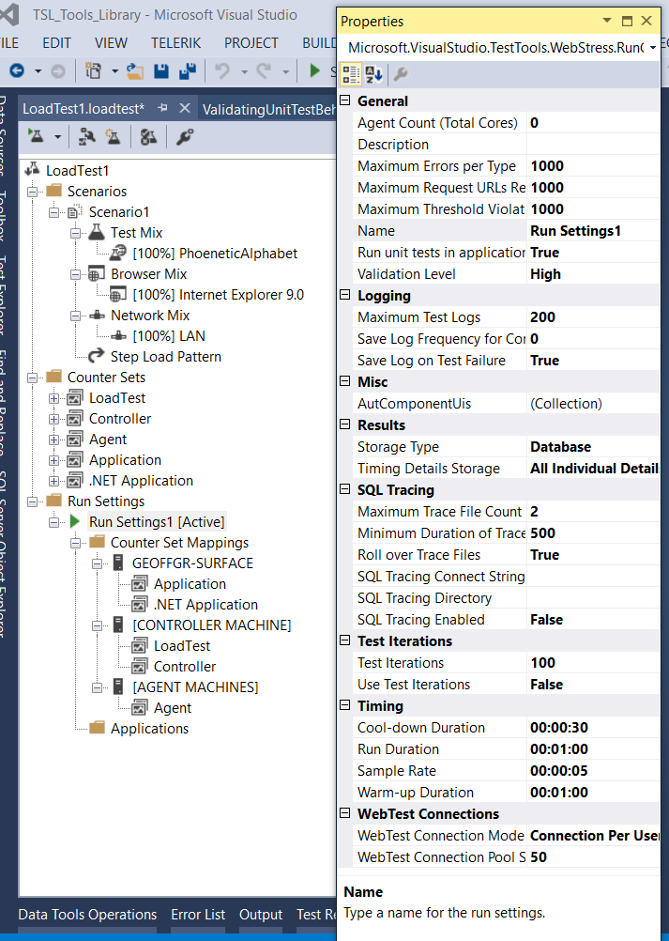
Leave this as “per user”
Saves the first 200 FAILED test details.
If Frequency = 1, saves every iteration until it reaches 200 saved.
If Frequency = 100, saves one out of every 100 passed iterations and all failed iterations until it reaches 200 saved.
Make sure this is set to “All Individual Details”

Scenario Settings

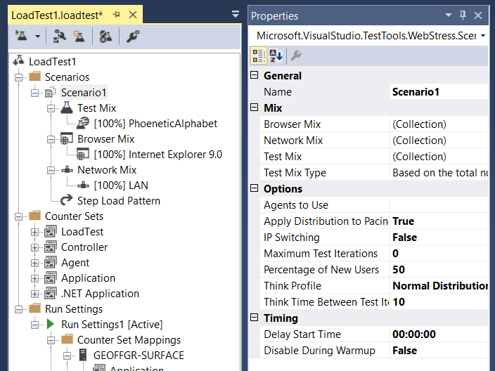

Step Load Patterns

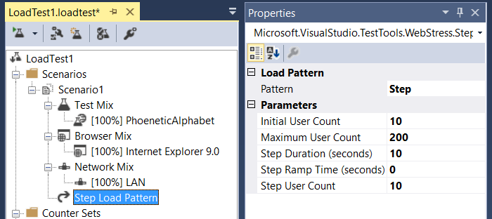

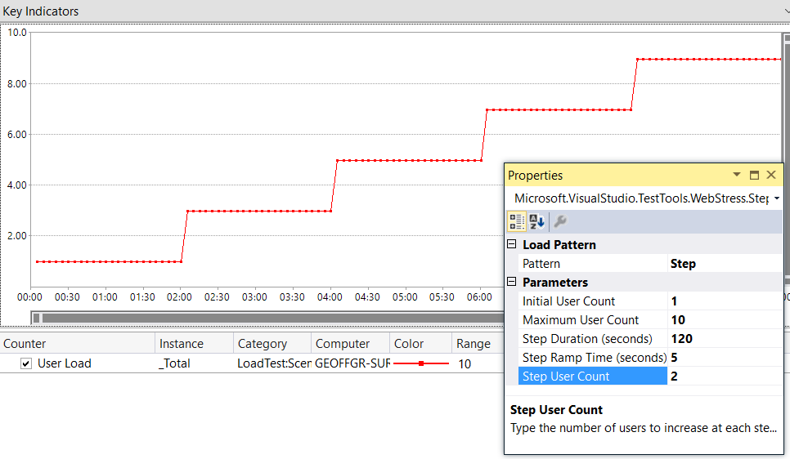

Using Login/Initialize Tests

Creating a nested test
If a user needs to login at the beginning of a session and then perform multiple tasks (webtests) without logging out, then use a separate webtest for the login and set that as an “initialize test”:
- Build the entire webtest as a single test and get it running fully (with parameters, etc.)
- Extract the login portion into a separate test:
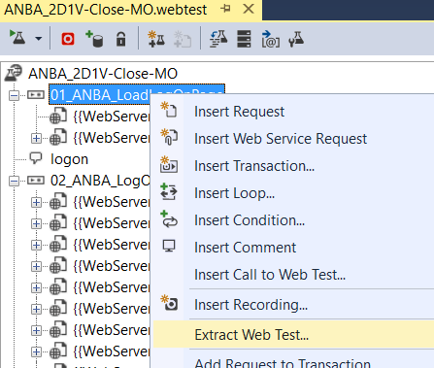
- Choose the appropriate items in the dialog box
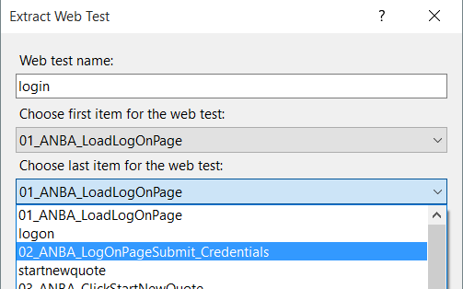
2
1
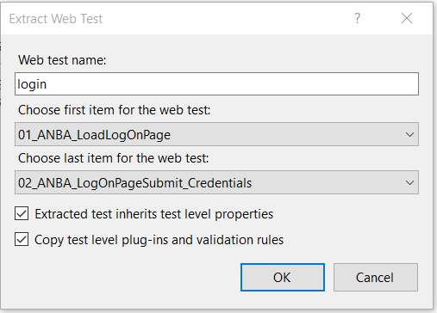
3
- Select OK. The test has been removed from the main test, saved and added as a call to the test:
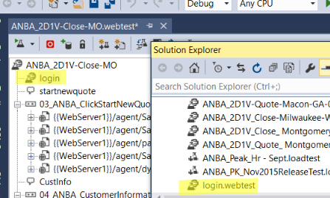
- If you open the login test, you will also see that the contexts, etc have been carried forward.

Setting up the webtests to use in a load test
When we need to run the main webtest by itself, we will want it to call the login webtest. Therefore, we leave the call in the main test.
In order to simulate load, we need to add the login test to the load test as an initialize test. We then need to ensure we do NOT call the login test from the main test. We could remove the call, but then the webtest would break when we ran it solo. A better way to handle this would be to put the call inside a conditional loop that only executes when running solo. This is how we can make that happen.
- Create a webtest plugin that fires on the “PreWebTest” event and checks to see if we are running inside a load test. If we are, then we add a context parameter called “InLoadTest”.
- Now we can add a conditional and see if the context exists. If it does, then do NOT execute the call. If it does not exist, then execute the call.
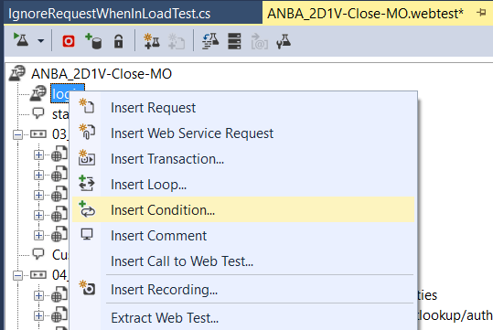
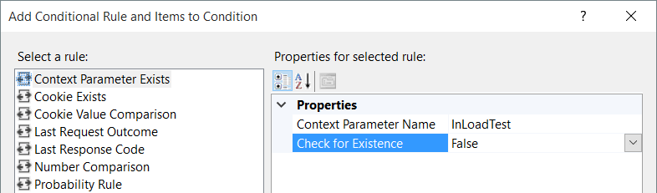
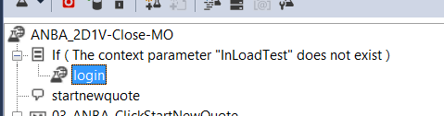
Finally, add the plugin:
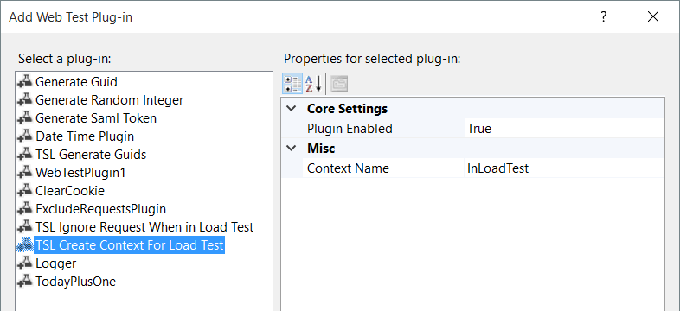

Code for the plugin
[DisplayName("TSL Create Context For Load Test")]
[Description("The context described will be created only when the webtest runs as part of a loadtest.")]
public class Test_Level_SetContextForLoadTest : WebTestPlugin
{
[DisplayName("Plugin Enabled")]
[Description("If set to FALSE, the plugin will not perform any work")]
[Category("Core Settings")]
[DefaultValue(true)]
public bool bEnabled { get; set; }

[DisplayName("Context Name")]
[Description("Name of the context that gets created when running in a load test")]
[Category("")]
[DefaultValue("InLoadTest")]
public string contextName { get; set; }

public override void PreWebTest(object sender, PreWebTestEventArgs e)
{
if (bEnabled)
if (e.WebTest.Context.ContainsKey("$LoadTestUserContext"))
e.WebTest.Context.Add(contextName, "");
}
}

Load Test Architecture

Load Test Properties

Run Settings Collection

Run Settings Properties

Counter Set Mappings

Applications
(2015 and newer only)

Location

Scenarios Collection

Scenario Properties

Test Mix

Browser Mix

Network Mix

Load Pattern

Counter Sets Collection

Load Test Plugins Collection

Load Test Execution

Advanced Topics

Performance Counters
- Item

Initial Test Analysis
- Item

Log Analysis
- Item

Tooling Your Application For Testing
- Item

Final Thoughts

Part 3 – References

Definitions
- Item

Execution Checklist
- Item

- Item

- Item

Items that need to be added somewhere in the doc
[CALLOUT] Think about it this way, the test harness and rig are a server-side application which must not become the bottleneck to your testing.

How timeouts play into analysis
- Webtest Request Property Timeout(Seconds) – The number of seconds Visual Studio will wait before giving up on getting a response. When this threshold is met, the request will fail, the connection will be recycled back to the pool and the webtest will either continue (Stop On Error = False) or abort (Stop On Error = True).
- Loadtest – There are no properties in a loadtest that deal with timeouts
- .testsettings file Test Timeouts tab – “Abort a test if…” tells Visual Studio to abort the current iteration of a web or unit test in a load test if the amount of time executing the iteration exceeds the given value. This is the overall time from the second the iteration starts and includes any client side rule processing, think times, response times, etc.
- .testsettings file Test Timeouts tab – “Mark an individual test as failed if …” tells Visual Studio to continue executing the current iteration of a web or unit test in a load test if the amount of time executing the iteration exceeds the given value, but mark the iteration as failed even if all requests succeed. This is the overall time from the second the iteration starts and includes any client side rule processing, think times, response times, etc.
- .testsettings file Unit Test tab – these settings have NO BEARING on a load test
- .testsettings file Web Test – these settings have NO BEARING on a load test

- You had request timeouts set to 15 seconds for the calls, but the server timeout was set to 22 seconds. That meant that the webtest iteration could fail (16 seconds) even though the server still had 7 seconds left to complete work. The default value for timeout is 300 seconds which would work for your tests, so we decided to change the values back to 300
- While making these changes someone mentioned that the server does NOT return a timeout error when it reaches 22 seconds. Therefore the requests set with a 300 second timeout will keep waiting the full 300 seconds. That’s when I said we should set the request timeout to 23 seconds. This would allow the server its full 22 seconds to respond but handle the server timeouts without showing the response time as 300 seconds.
- This is one reason why I break out results based only on success. If the request times out, regardless of 23 or 300 seconds, the result is marked as a failure. When I show response times for only successes, the timeout values do not distort the summaries.

How can a 90% value be less than an average time value
- The 90% value is calculated by taking the top 10% slowest response times, then getting the fastest time inside that 10 % Thus 90% of the response times are equal to or faster than this particular response time.
- The average is gotten by summing all of the response times and then dividing by the total number of responses.
- The Median (not reported by Visual Studio, but added for completeness) is calculated by ordering all values smallest to largest, then taking the value smack in the middle (think of it as a 50% value in general).

If you look at the way the above formulas work, it is always mathematically possible to get “weird” results like below, but <statistically speaking> it is just not common. To help illustrate this, I have created a fictitious data set and calculated all of the above items for it. You will see in my data set that 90% is quite a bit lower than the average…
time | total | Average | Median | 90 Percentile
1 | 29 | 1.45 | 1 | 1
1
1
1
1
1
1
1
1
1
1
1
1
1
1
1
1
1
1
10

See the section on ‘The Difference between USERS and VUSERS’ for more information.
Some rules do not fire on all generated requests, such as dependent requests or redirects. See the section on Advanced Topics – Request for more information.

